Name: ______________________________ Unit 5 Cell Division
Period: _______ Page: ______
Unit 5 Topic Reviews
Topic 1: DNA Organization
- Explain the difference between the following terms: chromatin, chromatid and chromosome.

- How many chromosomes are in human body cells? _________ Human sex cell? __________

- Provide two reasons why cells need to divide and what process must occur in the nucleus before they divide.

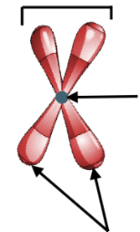

- Label the image below with the following terms: sister chromatids, chromosome, centromere.

- How is surface area to volume ratio calculated? What size cells are most efficient?

  - You will have to calculate SA:V ratio for two cells on your quiz! Practice:
Cube
Surface Area | L x W x 6 (# of sides)
Volume | L x W x H
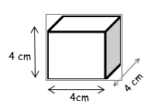
Topic 2: Mitosis
- What is the cell cycle? Which phase or stage do cells spend majority of their time in?

- What happens at each phase of interphase?

- How is prokaryotic cell division different from that of eukaryotes?

- How is cytokinesis different in plant cells and animal cells? What is cytokinesis?

- What are some of the reasons why cells go through cell division? What does mitosis mean?

For each image shown below, identify the stage of the cell cycle represented in the image—interphase, prophase, metaphase, anaphase, or telophase. Provide at least two pieces of evidence to support your identification.
# | Image | Two Pieces of Evidence
1 | 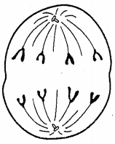
2 | 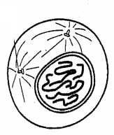
3 | 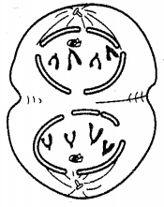
4 | 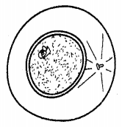
5 | 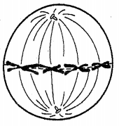

Topic 3: Meiosis
For each description given below, identify the stage of Meiosis I that corresponds to this description. Your options are prophase I, metaphase I, anaphase I, and telophase I / cytokinesis. The stage names may be used more than once.
# | Description | Stage Name
1 | Pairs of homologous chromosomes separate and travel to opposite ends of the dividing cell
2 | Pairs of homologous chromosomes come together and exchange segments of DNA (CROSSING OVER)
3 | The nuclear membrane and nucleoli reform around the chromosomes in the two daughter cells
4 | The fibers of the mitotic spindle push the pairs of homologous chromosomes to the center of the dividing cell.
5 | The cell membrane pinches in to divide the cytoplasm (including organelles) of the two daughter cells.
6 | The mitotic spindle is built.
For each description given below, identify the stage of Meiosis II that corresponds to this description. Your options are prophase II, metaphase II, anaphase II, and telophase II / cytokinesis. The stage names may be used more than once.
# | Description | Stage Name
7 | The nuclear membrane and nucleolus break down.
8 | The fibers of the mitotic spindle push the chromosomes to the center of the dividing cell, where they line up single file.
9 | The mitotic spindle breaks down.
10 | Pairs of chromatids separate and the daughter chromosomes move to opposite ends of the dividing cell.
11 | Daughter chromosomes uncoil into chromatin.
# | Image | Stage Name
16 | 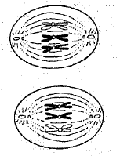
17 | 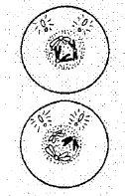
18 | 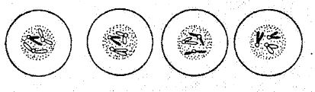
19 | 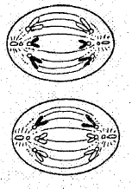
For each image given below, identify the stage of Meiosis that corresponds to this image.
# | Image | Stage Name
12 | 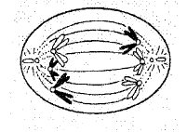
13 | 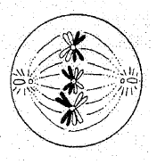
14 | 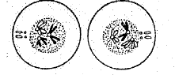
15 | 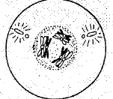

- What are sex cells called? ________________________________
- When two sex cells combine what is the new organism called? _________________________
- The normal chromosome number is called the ______________ number, 2n.
- The number after the reduction of meiosis is called monoploid or _____________ number, n.
- There are ________ rounds of nuclear divisions during meiosis. Resulting in ____ cells formed after cytokinesis.
- What are male gonads called? What kind of gametes are created here?
  - Male gonads:
  - Type of gametes:
  - Process name:
- What are female gonads called? What kind of gametes are created here?
  - Female gonads:
  - Type of gametes:
  - Process name:
Karyotypes
- Is this individual a male or female?
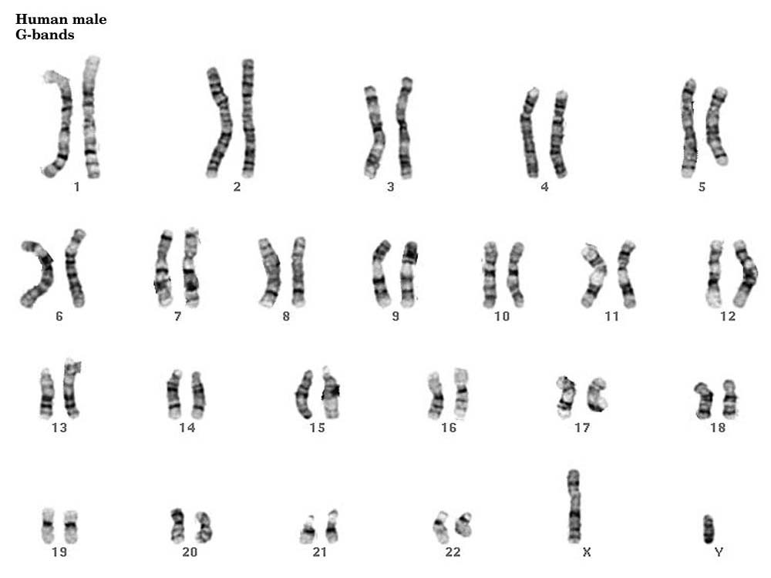

- How do you know?

- Did nondisjunction happen?

- What would you look for in an individual with trisomy?

- What would you look for in an individual with monosomy?

Topic 4: Cell Cycle Regulation
- ____________________ encode proteins (growth factors) for normal cell division.
- A ________________ or ______________________ causes a change in a DNA sequence that may result in cancer.
- _____________ is a disease of the cell cycle.
- ______________ is when cancer is described as “non-spreading”
- ______________ is when cancer is described as “spreading”
- A ____________ is a mass of cells, formed because of uncontrolled cell division.
- When a _________________ undergoes mutations, it can become a ________________ which produces growth factors uncontrollably, leading to loss of control in the cell cycle.
- The _______ checkpoint is often said to be most important. What are some things checked for at this checkpoint? (use your case study handout)
  - ____________________________________
  - ____________________________________
  - ____________________________________
  - ____________________________________
- Some cells do not divide. Rather than moving from G₁ to S, they enter into ___________
- ______________________________________ are responsible for stopping or decreasing the rate of cell division.
- When cells break off a tumor and travel through blood vessels to a new location, the cancer is __________________________________
- In cancerous cell division, neighboring cells ___________________________________ with each other.
- In normal cell division, neighboring cells __________________________________ with each other.
- People with cancer have cells going through ________________________ cell division.
- List some things that can cause mutations: ___________________________________________ ______________________________________________________________________________

