Name: ___________________________________________ Unit 6 Notes

Period: _______ Page: _____

**Unit 6 Notes: DNA, RNA, and Protein Synthesis**

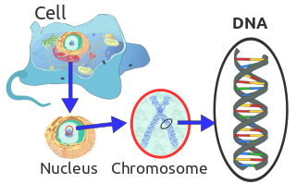**Topic 1: DNA History and Structure**

*By the end of this topic, you should be able to…*

1. *Identify the experiments and scientists involved in the discovery of DNA*
2. *Describe the structure of the DNA molecule*
3. **Review:**
4. *Define monomer: _____________________________________________*
5. *Define polymer: ____________________________________________________________________________*
6. *Monomer of nucleic acids: ____________________________*
7. *Who discovered the structure of DNA and what is it? _______________________________________________*
8. 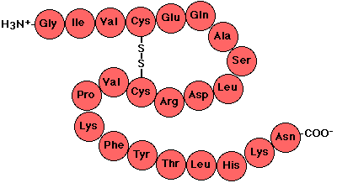**History of DNA**
9. Early scientists believed that _________________ was the genetic material of the cell.
   * **Explain why:**
10. Proteins are made of 20 different ___________________________________
11. Long chains of amino acids make up _________________________________ 🡪
12. **Frederick Griffith**
    1. Fred Griffith worked with ______________________ S and ___________________________ R strain pneumonia bacteria
    2. 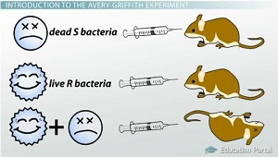Bacteria can be considered:
       * virulent (__________________________)
       * nonvirulent (___________________________)
    3. Mice were injected with:
       * living virulent bacteria
       * living harmless bacteria
       * dead virulent bacteria
       * dead virulent + live harmless
    4. **Mark** above with a checkmark which of the following bacterial combinations killed the mice
    5. Living bacteria used the _____ ability of the dead bacteria.
    6. The bacteria picked up ____ from their surroundings and used the code to make toxins.
    7. This is ______________________________________________.
    8. Griffith’s experiment suggested that _____________ is the cell’s genetic material.
13. **Hershey and Chase**
14. 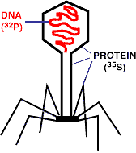Viruses are made of ____________ in a protein “coat”
15. Experiments on viruses by ____________________________ proved that DNA was the cell’s genetic material
16. __________________________ DNA was injected into bacteria!
17. How did Hershey and Chase’s work with viruses help to support Griffith’s idea?

1. 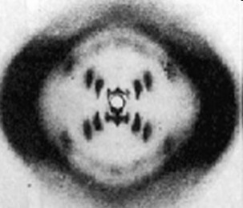**Rosalind Franklin**
2. ___________________________ took x-ray diffraction photographs of DNA crystals.
3. In the 1950’s, _________________ and ___________________ used Franklin’s x-ray diffraction photos to come up with the __________________________________________ model of DNA.

*You will now be using the article provided to describe the importance of each of the scientists’ discoveries to the structure of DNA. Use the article to answer the following questions about the different scientists.*

1. What happened in 1869 that lead us to call it a landmark year in genetic research?
2. How did Friedrich Miescher know that he had found a new substance when investigating pus-coated bandages (what was different about the substance)?
3. In one sentence, describe why Meischer’s discovery is important in understanding the structure of DNA.
4. What four things did Phoebus Levene do first?
5. In simple terms, what was Levene’s “polynucleotide” model (hint: break down the word polynucleotide for a simple explanation)?
6. What was one thing that Levene hypothesized that was later found to be incorrect?
7. What two major things did Erwin Chargaff discover with his research using chromatography?
8. What is Chargaff’s rule?
9. What did Franklin and Wilkins provide to Watson and Crick?
10. How did Watson and Crick go about building the structure of DNA?
11. In simple terms, what are the four major features of the Watson and Crick model?
12. What is one way that scientists has elaborated on the Watson and Crick model?

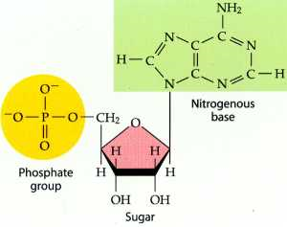

1. **The Basics of DNA Structure**
2. DNA is a type of _________________________________
3. ________________: Deoxyribonucleic Acid
4. Made of monomers called _____________________________________
5. Function of DNA: __________________________________________________
6. Double helix is formed by ***nucleotides*** linked to one another.
7. Each nucleotide made of three parts (label the image above and to the right with the following):

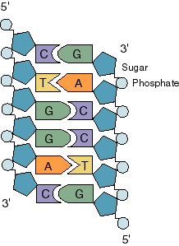

* + ___________________________________
  + ___________________________________
  + ___________________________________

1. **DNA**
2. DNA is made of two twisted strands called the _____________________________
3. The “backbone” or sides of each strand is made of a sugar **deoxyribose** bonded to _______________________ (PO4) groups.
4. The “rungs” or steps of the ladder are made of ________________________ bonded together by weak _______________________ bonds.
   * 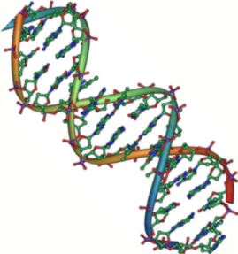The twisted helix is very stable.
   * But the _____________________________ are _____________________ and the two strands can be pulled apart when the helix is untwisted by an enzyme.
5. **Label** a ***sugar, phosphate,*** and ***base*** again in the picture with the arrows above and to the right.
6. **DNA Strands**

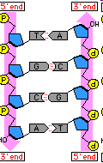

1. The part of a strand that ends with the _____________________ is called the ___________ **prime (5’) end**.
   * **Ph**osphate = **F**ive
2. The part of a strand that ends with the _____________________ is called the _________ **prime (3’) end.**
3. One strand of DNA goes from ______________________________
4. The other strand is ________________________ in direction going 3’ to 5’
5. Explain in your own words what it means for DNA strands to be **antiparallel:**
6. **Nitrogenous Bases – Pyrimidines vs. Purines**
7. Double ring structure: _______________________________

* Adenine (A)
* Guanine (G)

1. Single ring structure: _________________________________
   * Thymine (T)
   * Cytosine (C)
2. 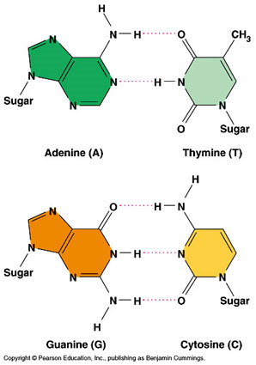**Base Pairings**
   * 1. Purines can only pair with pyrimidines.
     2. They are connected by _______________________ bonds. (See picture to the right)
     3. *Why would it be a problem for the double structure if purines paired with purines and pyrimidines with pyrimidines? _____________________________________________________________________ _____________________________________________________________________ _____________________________________________________________________*
     4. The process of specific bases pairing together to form the rungs of the ladder is called ______________________________________________________________
   * Chargaff’s rules state that
     1. **Adenine** must pair with ________________________
     2. **Guanine** must pair with ________________________
     3. **Erwin Chargaff** showed the ___________________ of the four bases on DNA. In the DNA of a body cell, he saw the following percentages:

A = __________ T = __________ G = __________ C = __________

* What do you notice about these numbers? ______________________________________________
* **Practice Question #1:** If there is 30% adenine, how much cytosine is present? _________________
* **Practice Question #2:** Write out the sequence of a strand complementary to the following strand.

T T A G C A T G G

**[[*Language Target for Topic 1: I can match the scientists and their research that aided in the discovery of DNA; I can create a model of DNA]]***

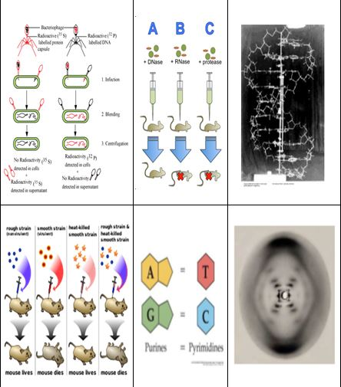1. Provide the name of the scientist(s) associated with each image provided. Do so by filling their name(s) in above or beneath the appropriate picture.

2. Complete the DNA Structure coloring assignment.

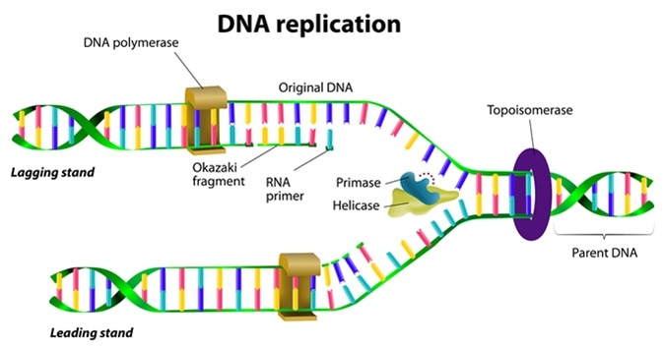**Unit 6, Topic 2: DNA Replication**

*By the end of this topic, you should be able to…*

1. *Identify the purpose of DNA replication*
2. *Identify and order the steps involved in DNA replication*
3. *Explain the purpose of molecules (enzymes) used in DNA replication*
4. **Replication Facts**
5. Cells must copy their DNA before they do what? _______________________________
   * Explain why: _________________________________________________________________________ ____________________________________________________________________________________
6. DNA is copied during the S or ______________ phase of ________________
7. [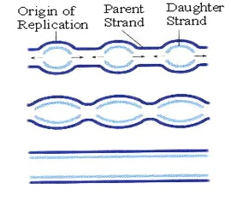](http://www.google.com/url?sa=i&rct=j&q=&esrc=s&frm=1&source=images&cd=&cad=rja&uact=8&ved=0CAcQjRw&url=http://kvhs.nbed.nb.ca/gallant/biology/replication_bubble.html&ei=xl7GVM_pJcm0yASU0oK4Cw&bvm=bv.84349003,d.aWw&psig=AFQjCNGDU2iWql-qMmG7LBKzZ-TIOmnQzA&ust=1422372921718055)Where does DNA replication take place in eukaryotes? _____________________________________________ (remember, DNA cannot leave this location! It’s too big)
8. **DNA Replication**
9. Replication of DNA begins at points called ________________________________________________________
10. The two strands open forming _________________________________________________ (Y-shaped areas).
11. *New strands of DNA grow at the forks.*
    * Prokaryotes (bacteria) have a _____________________ bubble.
    * Eukaryotic chromosomes have _____________________ bubbles.

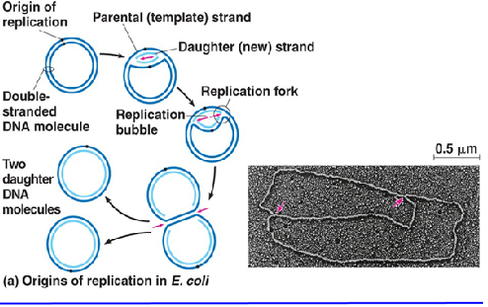 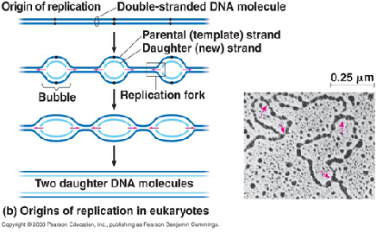

1. **Label** the ***replication fork*** and the ***5’*** and ***3’*** ends of each parent strand on the picture below.

*Recall: Why are the 5’ and 3’ ends arranged like this?*

**Parental DNA Molecule**

1. **Replication is semi-conservative** 
   1. Each original strand is conserved
   2. New double helix has _____________________________ of the original two strands

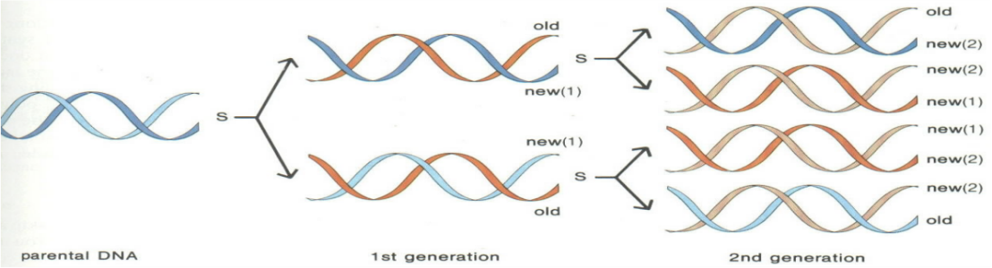

**Helicase**

1. **Steps of DNA Replication**
2. 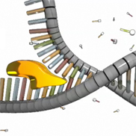The enzyme ________________ unwinds and separates (“unzips”) the 2 DNA strands by breaking the weak _______________________ bonds between bases.
3. ___________________ gathers ___________________________ and brings them into the replication fork.
   * + 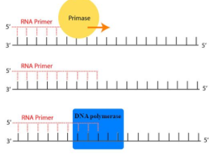 A “______________” is created by the enzyme ___________to start the new strand. This is made with ________ nucleotides rather than DNA nucleotides.
4. The enzyme ________________________________ matches free nucleotides with the correct base pairs on the ___________________ (parent) strands. This enzyme creates the daughter strand.
5. The enzyme ______________________ removes the RNA primers and then DNA Polymerase replaces them with _______ nucleotides.
6. The enzyme _________________ connects/seals any “gaps” in the new strands.
   * ***The Big Question****: Why are there “gaps” in the new strands at all?*
     + DNA polymerase can only add nucleotides to the ________ end of the DNA.
     + This causes the ______________ to be built in a ______ to ______ direction.
       - (“**build”** is **5** letters, so building any nucleic acid always goes in that direction)
     + Remember that DNA must be ____________________________.
     + The _________________ strand is built into the replication fork and is built as one continuous unit.
     + The _________________ strand is built in short sections called __________________________________ in the ________________direction (out of the fork). This causes the “__________” in the strand.
7. **Label** the ***leading strand, lagging strand, DNA polymerase, helicase, and primer*** in the picture on the next page.

**Again, label** the ***leading strand, lagging strand, DNA polymerase, helicase, and RNA primer*** in the picture. Also label the ***5’ and 3’ end of each of the daughter strands.***

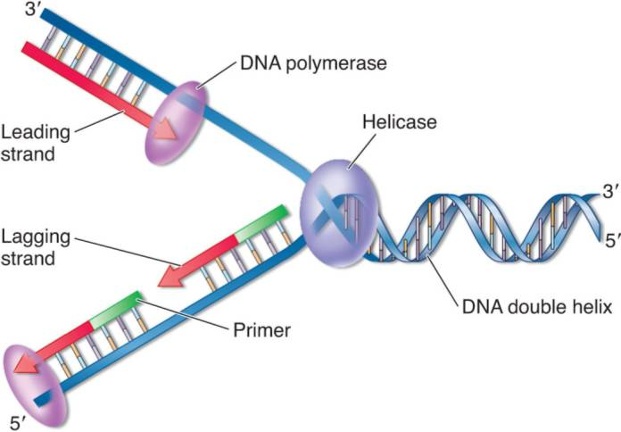

1. **Proofreading New DNA:**
2. DNA polymerase makes about ________________________ base pairing errors.
3. _______________ proofread and correct these mistakes
4. The new error rate for DNA that has been proofread is ______________________________ base pairing errors.
   * **How does the DNA get damaged?** 
     + ________________ and ______ radiation damage the DNA in our body cells.
   * **Types of** **DNA repair**
     + ____________________ - when a repair enzyme removes damaged DNA.
     + _____________________ and ___________________ work together to replace and bond new nucleotides together.

**[[*Language Target for Topic 2: I can explain the purpose of DNA replication; I can sequence the steps in DNA replication; I can provide the name of the enzyme involved in each step of DNA replication]]***

1. Number the steps of DNA replication in the correct order (1, 2, 3):

_____ Daughter strands are formed using complementary base pairing.

_____ DNA unwinds

_____ The DNA of the daughter strands winds with together with its parent strand.

1. Why is DNA replication called “semi-conservative”?
2. What enzyme unwinds or unzips the parent strand?
3. What enzyme connects the new DNA bases to the old bases of the template strand, and then proofreads them?
4. What enzyme seals any “gaps” in the new strand together?

*Using the DNA provided, complete the following:*

1. Label the 3’ and 5’ end of each strand (you decide which is which)
2. Label the replication fork
3. Draw and label helicase
4. Label the overall direction of DNA replication
5. Draw in a primer
6. Draw and label the leading strand (with its 5’ and 3’ end)
7. Draw and label DNA polymerase (you will probably draw several)
8. Draw and label the lagging strands (with their 5’ and 3’ ends)
9. Draw an arrow showing one place where ligase will have to seal/connect the backbone of the new strand.

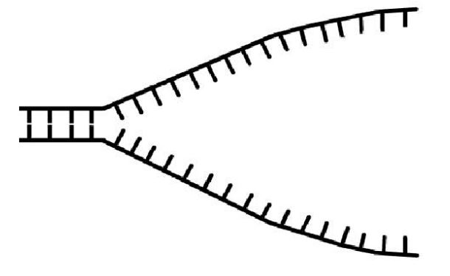

**Unit 6, Topic 3: Protein Synthesis**

*By the end of this topic, you should be able to…*

1. *Describe the differences between DNA and RNA*
2. *Identify and order the steps in protein synthesis (transcription and translation)*
3. *Explain the purpose of the molecules used in both transcription and translation*
4. *Use a codon chart to determine a protein sequence based on an mRNA code*
5. *Compare and contrast gene and chromosomal mutations*
6. *Predict the effect of DNA mutations on the resulting protein*
7. **What are Proteins?**
8. Hershey and Chase’s virus experiment (Topic #1) showed that __________ was the genetic material of the cell.
9. Proteins are the “______________________” of the cell…they do a lot of different jobs!

A) _____________________- immune system/defense

B) ____________________- hair/nails

C) ____________________ - enzymes

D) ____________________ - transport (membrane proteins or hemoglobin that carries oxygen in blood)

E) ____________________ - muscle

1. Proteins are made up of Amino Acids
   * 1. 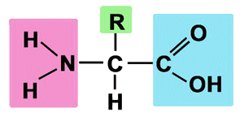Amino Acid Structure (Label the image to the right)
        1. Amine Group
        2. Carboxylic Acid
        3. Variable Group
        4. H – atom
     2. A molecule of is lost between the acid and the amine group
        1. The process is called__________________________
     3. 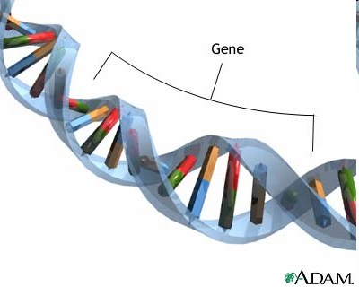A bond forms between the C & the N atoms of neighboring amino acids.
2. **How do our Cells Make Proteins?**
3. DNA contains ___________________, sections of nucleotide chains.

Genes code for__________________________ (proteins).

Polypeptides are ____________________________ chains.

1. **The Dilemma:** DNA is found in the _____________________, but proteins are made in the _________________________.
   1. 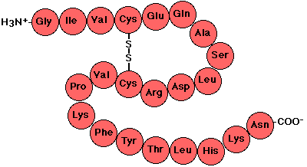How do we get the message from one place in the cell to another?
2. **The solution:** A molecule called ________________carries the message from the nucleus to the cytoplasm!
   * 1. Unlike DNA, RNA is small enough to fit through the ________ in the nuclear membrane
     2. DNA is the __________________, RNA is the _______________of the master plan!
3. **Putting it together so far:**

* _________ is responsible for ***controlling*** the production of ___________ in the cell, which is essential to life!
  + DNA🡪RNA🡪Proteins
* _________________ contain several thousand ___________, each with directions to make one ___________
* **Remember,** proteins are produced in _______________________!
* Found in two places:
  + Free floating in _______________
  + Attached to _______________________
* How does information needed to build a protein gets delivered from the DNA to the ribosomes?

1. With the help of ___________ (like a messenger) in a process called ______________________
2. 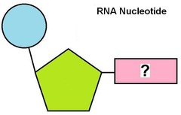**What is RNA?**

* ***RNA*** stands for __________________________________
* One subunit is called a _______________________
  + 1 5-carbon __________________ (ribose)
  + 1 ____________________ group
  + 1 nitrogen (N) _____________
* Three types of RNA: ____________________________________

1. 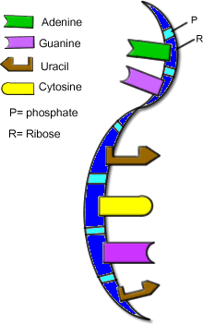**How is mRNA different from DNA?**
   1. Number of Strands
      1. DNA 🡪 ____________________
      2. 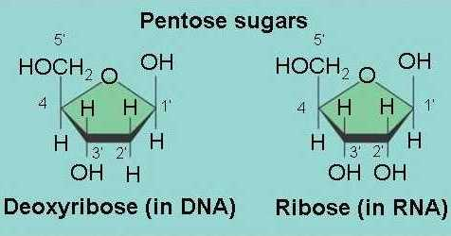RNA 🡪 ____________________
   2. Nitrogen Bases
      1. DNA 🡪 ____________________
      2. RNA 🡪 ____________________
   3. Sugars
      1. DNA 🡪 ____________________
      2. RNA 🡪 ____________________
   4. Size
      1. DNA 🡪 ____________________
      2. RNA 🡪 ____________________

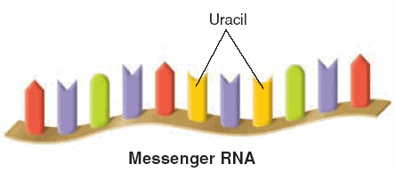

1. **3 Types of RNA**
   1. **Messenger** RNA (mRNA) copies DNA’s code & carries it to the ribosome
      1. Long Straight chain of ________________________
      2. Made in the Nucleus
      3. ____________________________________________ through nuclear pores to the ribosomes
         1. This is so a cell can begin assembling ____________________, the building blocks of ______________________!
         2. It’s sending a __________________ on how to do the job!
      4. Contains the Nitrogen Bases A, G, C, U ( no T )
   2. 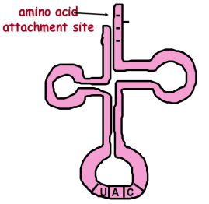**Transfer** RNA (tRNA) takes amino acids to the ribosomes, where they can be joined into a chain
      1. Clover-leaf shape
      2. Has an attachment site at one end for an amino acid
         1. each tRNA carries a __________________________________
   3. **Ribosomal** RNA (rRNA) makes up the ribosomes
      1. Globular in shape
      2. Together with proteins, makes up ribosomes
2. **Overview of Protein Synthesis**

* ***Protein synthesis*** has two stages: _______________________ & ___________________________
  + A ________________________ molecule (mRNA) carries instructions from DNA to ribosomes
    - DNA ___________________ leave the nucleus; ___________ can!
    - ____________ makes it possible for ____________ to be assembled by _____________ outside the nucleus

1. **Protein Synthesis: Transcription (Part 1)**
2. ***Transcription*** is when _________ is used to make _________
3. Happens when _________________ need to be made in the __________________
4. Since DNA CANNOT leave the ______________, it is ____________________ into RNA (DNA🡪RNA)
   1. Transcribe: _______________ (copy in the same nucleic acid language, but only what is needed!)
5. How does it happen?
   1. DNA ____________________
   2. ______________________________ (an enzyme) matches RNA bases with the DNA gene template (transcription) to make an mRNA strand. This will continue until an enzyme signals “the end.”
   3. mRNA is released and leaves the ________________ through a nuclear _______________.
   4. Now it is free to travel into the ________________________ and attach to a _____________________.

*Think about it:* What is happening in each photo below during transcription?

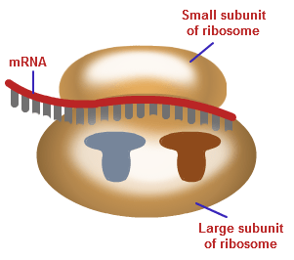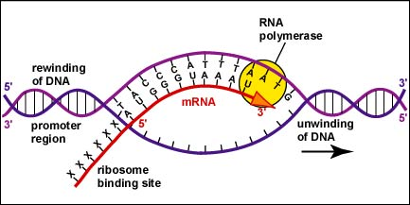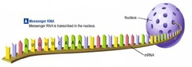

1. Transcribing DNA to mRNA is very easy if you remember these ***complementary*** pairs!
   * _______ (in RNA) will attach to a ______ (in DNA)

Check your Understanding:

https://goo.gl/JrWA3E

**Score on the Transcription Check:**

* + _______ (in RNA) will attach to a ______ (in DNA)
  + _______ (in RNA) will attach to a ______ (in DNA)
  + **_______ (in RNA)** will attach to a ______ (in DNA)

1. Try it!
   * A piece of DNA reads: T A G C A T T C C G A U

Transcribe to mRNA: _____________________________________

* + 1 side of DNA reads: A A G C G T A T C C C G

Transcribe to mRNA: _____________________________________

1. **Protein Synthesis: Translation (Part 2)**

* ***Translation*** 🡪 The process in which ________ is used as a ______________________ to form chains of ______________________________ (RNA🡪Protein)
  + Amino acids linked together form a _____________________
  + Translate: To change a sentence from one language (________________) to another (______________)
* Every group of 3 letters on an mRNA chain = _________________
* Each codon (3 mRNA letters) codes for 1 _____________________
* Given the ________, we can read a __________ chart to translate it into amino the amino acid it codes for!
  + 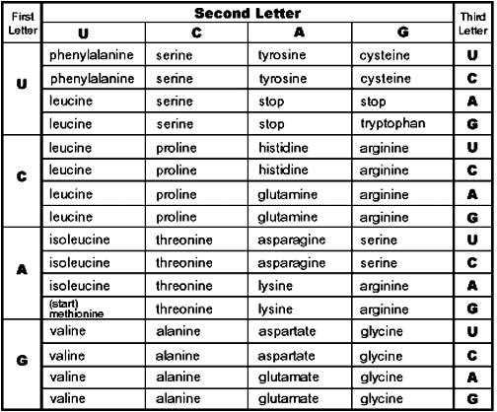Remember, 1 word in nucleic acid language is a ____________ (three nucleotides)

*Think about it*: What amino acid is coded for?

1. AUG ____________________
2. GUC ____________________
3. GCC ____________________
4. CGA ____________________
5. UAA ____________________

* ***Translation*** occurs in _______________ in ALL cells
* Uses all three forms of RNA (______________________________________)
* DNA is not directly used!

1. 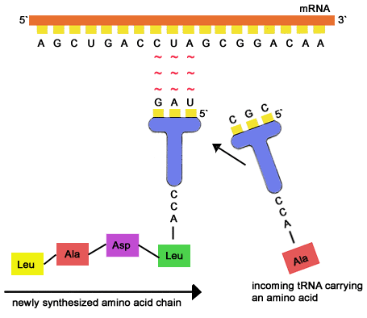**Steps of Translation**

**tRNA: A Closer Look**

* Notice the tRNA is carrying the amino acid leucine, coded for by the sequence “CUA”
* The tRNA knows how to match using bases!
* So…mRNA codon reads “CUA,” so the tRNA anticodon will be “GAU”

1. 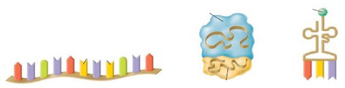The mRNA leaves the _________________ and lands on a ________________ (rRNA).
2. _________ (with correct anticodon) lands on the ribosome opposite a __________ on the mRNA.
3. The tRNA leaves the ribosome, but the _____________ _________ that it coded for stays on the ribosome to wait for next codon to bring another amino acid to bond to.
4. The ________________ moves to the next __________ bringing in another ____________________________ to the growing amino acid chain

* The amino acid chain will ALWAYS begin with the “___________________”- AUG
* The tRNA will continue to add amino acids until it reaches a “_____________________” (UAA, UAG, UGA)
* When it reaches a stop codon, then a complete _____________________has been built! The protein ___________________ from the ribosome.

*Think about it*: Label the diagram of translation to the right with the following terms!

1. ribosome
2. mRNA
3. tRNA
4. codon
5. anticodon
6. amino acid chain

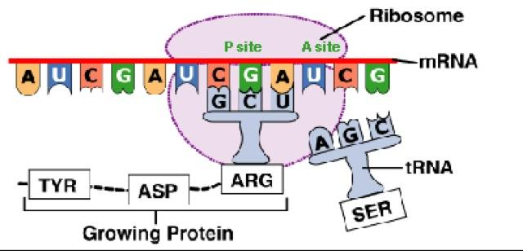

Let’s Practice!

* Given the template strand of DNA🡪 **ATC**
  + What would its *complementary* DNA strand read? ________
  + Now, transcribe the template DNA to mRNA __________
  + What amino acid does the codon code for? (use chart) _________
  + What would the anticodon on tRNA read? __________
* Given the template strand of DNA🡪 **TGA**
  + What would its *complementary* DNA strand read? ________
  + Now, transcribe the template DNA to mRNA __________
  + What amino acid does the codon code for? (use chart) _________
  + What would the anticodon on tRNA read? __________

**Review Table**

|  |  |  |
| --- | --- | --- |
|  | Transcription | Translation |
| Starting Molecule |  |  |
| Ending Molecule |  |  |
| Where it happens? |  |  |

1. 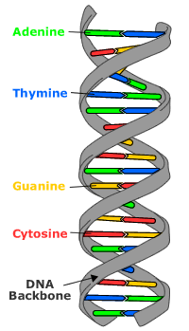**Mutations Overview**
   1. A mutation is a change in the sequence of ___________ ____________(A, T, C, and G’s) in the DNA code.
   2. Recall from our study of protein synthesis that the sequence of bases in DNA ultimately codes for sequences of _________________________ found in protein. Therefore, any change in the DNA sequence will affect the resulting polypeptide.
   3. There Are 2 Main Types of Mutations**:**
2. Gene Mutations - a mutation that involves ___________________________________
   * 1. These are ____________ scale mutations (only one gene is affected)
        1. Point Mutations: one base in the sequence is ______________________, which may or may not change the resulting protein (more info below).
        2. Frameshift Mutations: one base in the sequence is added or ___________________ which changed the whole “reading frame” (groupings of codons).
3. Chromosomal Mutations - a mutation involving ___________________________________________
   * 1. These are _____________ scale mutations (many genes are affected)
4. **Types of Mutations – Gene Mutations (Base Sequence Changes)** 🡪 There are two types of mutations based on their effect on the resulting polypeptide: point mutations and frameshift mutations.
   1. ***Point Mutations:*** these mutations are caused by a _____________________ in the DNA sequence (one base is exchanged for another)
      1. ***______________________****:* the DNA change results in an mRNA codon that codes for the same amino acid as the original sequence, there will be ***no effect*** on the resulting polypeptide
      2. ***______________________****:* the DNA change results in an mRNA codon that codes for a different amino acid as the original sequence, there will be a change in ***one amino acid*** in the resulting polypeptide.
      3. ***______________________****:* the DNA change results in an mRNA codon that does not match with any amino acid (i.e., the stop codons UAA, UAG, and UGA), then the creation of the polypeptide will ***stop early and it will not code for a functional protein***.

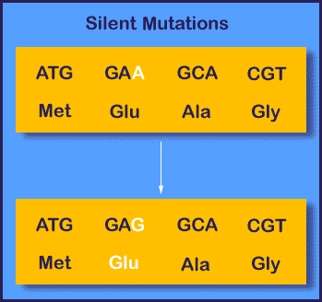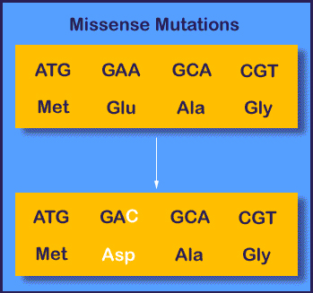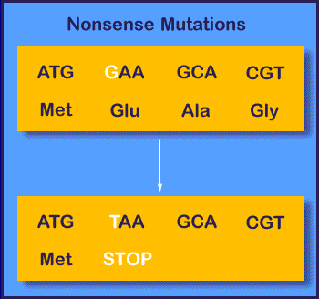

* 1. ***Frameshift Mutations:*** these mutations are caused by an _____________________ or _____________________ of bases in the DNA sequence. Since DNA codes for mRNA that is divided into codons that are three bases long, insertions and deletions in the DNA sequence can alter a gene so that its message is no longer correctly “grouped.” If there is a frameshift mutation early on in a protein-coding DNA sequence, all amino acids created after the mutation will change.
     1. For example, consider the sentence, “The fat cat sat.” Each word represents a codon. If we delete the first letter but still arrange the letters in groups of three, the sentence no longer “makes sense.” Instead, it would read _________ ________ ________ _______.
     2. An image of a frameshift mutation is on the next page.

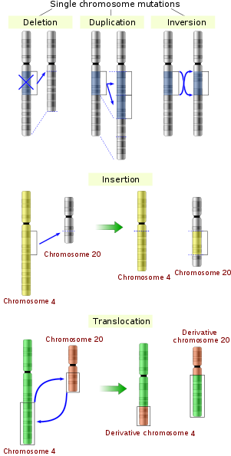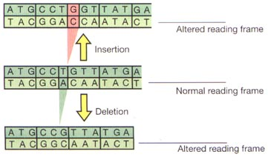

1. **Types of Mutations – Large Chromosomal Mutations (image to the right)**

Mutations that involve changes in large “chunks” of a chromosome are called chromosomal mutations. Several types are listed below:

_______________________: A large section of the chromosome is copied.

_______________________: A large section of the chromosome is flipped around.

**_______________________**: A large section from one chromosome is stuck into another.

_______________________: Large sections from two chromosomes are switched.

1. **Causes of Mutation:**
   1. 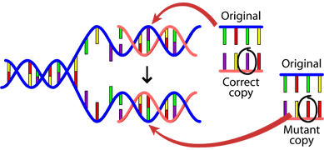 ***DNA fails to copy accurately:*** Occasionally _________________________ will make an error when pairing new nucleotides with nucleotides on the template strand of DNA. It may match a C with an A, rather than a T with an A.
   2. ***External influences:*** Mutations can also be caused by exposure to specific chemicals or radiation that are called _______________________. These factors cause the DNA to break down. This is not necessarily unnatural – even in the most isolated, perfect environment, DNA breaks down. The cell has enzymes that are used to repair DNA. However, if these enzymes do not perfectly repair the errors caused by mutagens, a true mutation results.
2. **Can Mutations be Passed Down to Offspring?**
   1. Although mutations can happen in any of our somatic cells, ***only mutations present in ______________________*** will be passed down to offspring.
3. ***KEY IDEA****: A mutated _______________ will make a mutated _______________________.* 
   1. *Mutant proteins are trouble!*
      1. *They do not ______ where they’re supposed to go.*
      2. *They do not ______ what they’re supposed to do!*

**[[*Language Target for Topic 3: I can create a Venn diagram to compare and contrast RNA and DNA; I can transcribe a strand of DNA into mRNA, and then translate it into the appropriate amino acid sequence using the codon chart; I can locate an mRNA codon on the codon chart to determine which amino acid it codes for; I can discuss and compare the various mutations]]***

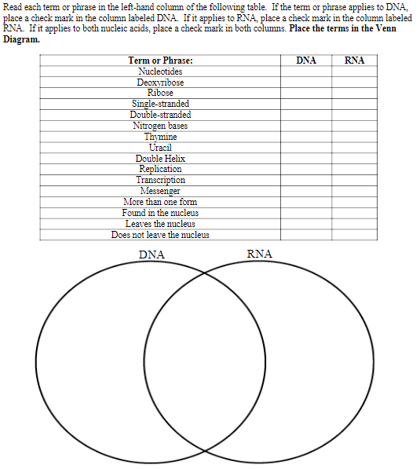

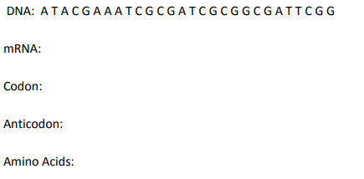

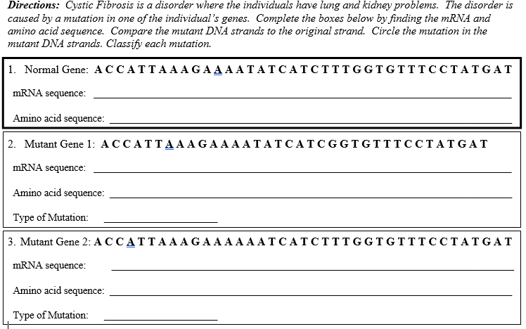

**Unit 6, Topic 4: Biotechnology**

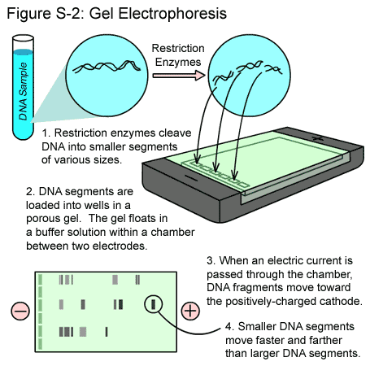*By the end of this topic, you should be able to…*

1. *Describe the purpose and methods of gel electrophoresis and analyze electrophoresis results*
2. *Provide examples of the practical uses of biotechnology, including insulin production and cloning*
3. *Describe the purpose and methods of PCR (polymerase chain reactions)*
4. Genetic Engineering = _______________________________________
   1. With present technology and knowledge of DNA structure, we can extract, identify, modify, copy, and transfer DNA sequences!
   2. Genetic engineering allows scientists to create _____________________ traits within organisms to meet specific needs without relying on natural mutations.
5. PCR (polymerase chain reaction)
   1. PCR is the artificial _______________________________ of DNA in a controlled environment.
   2. We use heat to separate the strands and special heat-resistant bacterial enzymes to speed up the process
6. Extracting DNA - (first step to genetically engineer an organism)
   1. DNA extraction is relatively easy to do from the cells of plants and animals! We can even do it in the classroom!
   2. Once you have extracted the DNA, you can ______________________________ ______________________________ it in helpful ways
7. Cutting DNA – (second step)
   1. Remember: DNA is a very long molecule
   2. 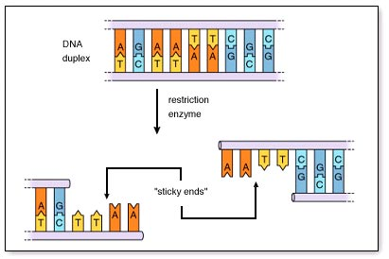In order to make working with DNA more manageable, scientists use ______________________________________________________ to cut DNA into fragments known as restrictive fragments.
   3. These restrictive enzymes are chemicals that bind to and make cuts at specific sequences in DNA.
8. Separating DNA (third step)
   1. Once DNA is cut into fragments, scientists select only those sequences that code for particular traits.
   2. Gel electrophoresis is one technique that is used to sort DNA sequences by _________________, which can be read and analyzed.
   3. Once it is sorted, scientists can…
      1. study individual genes on the DNA
      2. obtain a segment of DNA to copy using a technique called PCR (polymerase chain reaction)
      3. help locate genetic diseases to potentially eliminate them
9. Changing DNA (fourth step)
   1. Like Frederick Griffith’s early bacterial transformation, scientists are able to take segments of one organism’s DNA and place it into the _________________________ of other organisms
   2. 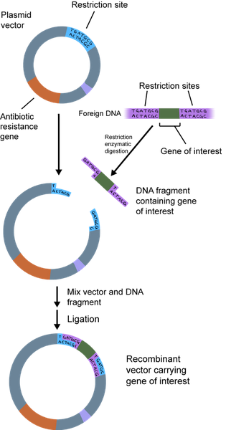Recombinant-DNA Technology is the type of genetic engineering where DNA from two are more different sources is joined (resulting in what are called ______________________________ organisms)
10. Steps in Transforming Bacteria
    1. Recombine DNA-restriction enzymes like *Eco*RI cut the DNA into fragments to prepare them for recombination
    2. Transport DNA-a scientist has to insert recombinant DNA pieces into the host cell (into plasmids, or circular DNA, in bacterial cells)
    3. Transfer DNA- When the host cell divides (by binary fusion), it also makes a copy of the newly transformed plasmid (called a recombinant plasmid)
    4. Genetic markers, such as those for antibiotic resistance, inserted into the plasmid along with the specific desired gene allow scientists to pinpoint transgenic cells
11. Uses of Recombinant DNA Technology
    1. Advances in medicine
       1. Transgenic animals and plants that provide ___________________________________
       2. Transgenic animals used as test subjects
       3. Insulin or Human Growth Hormone production by bacteria
       4. Human Genome Project & Gene Therapy
    2. Agriculture
       1. 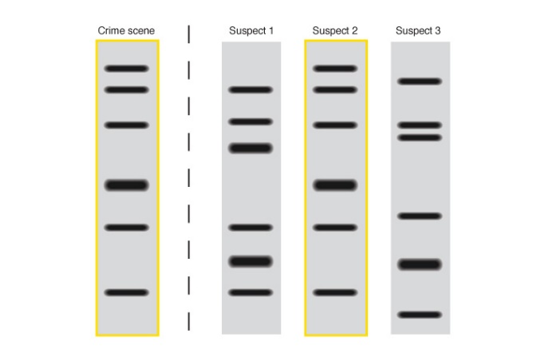Genetically modified plants and animals (their cells don’t accept foreign DNA very well so you must infect plant and animal cells with bacteria containing recombinant plasmids)
    3. Personal identification
       1. DNA fingerprinting
       2. Paternity testing
       3. Forensic science
    4. Cloning
       1. When humans clone, they use a single cell of an adult organism to grow a new genetically identical individual
       2. They Inserts the nuclei from the blastula stage (hallow ball of cells after several divisions of a zygote) of an embryo into an adult cell 🡪 Ex. Dolly the sheep
12. Human Genome Project
    1. The goal was to determine the sequence of nitrogen bases in human DNA. An entire set of DNA from a body cell is considered that organism’s genome.
    2. There are _____________________________________________ in the human genome and approximately 25,000 genes.
    3. NIH is striving to cut the cost of sequencing an individual’s genome to $1,000 or less. Having one’s complete genome sequence will make it easier to diagnose, manage and treat many diseases.

**[[*Language Target for Topic 4: I can interpret gel electrophoresis results through writing; I can compose a written list of the practical uses of biotechnology; I can explain the purpose and methods of polymerase chain reaction]]***

