Name: ___________________________________ Date: __________________________ Period: ___________

Unit 6, Part 1 Notes: DNA Organization, the Cell Cycle, and Mitosis
AP Biology
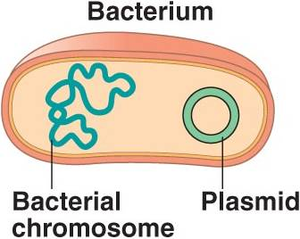
1. How do prokaryotes organize their DNA?
- Prokaryotic organisms like bacteria are always unicellular (single-celled).
- Bacteria have a single, large loop of DNA called the circular chromosome. They may also have several tiny loops of DNA called plasmids.
- The chromosomal DNA and plasmid DNA in a prokaryotic cell make up its genome. A genome is defined as an organism’s complete set of DNA.

2. How do prokaryotes reproduce?
- When bacteria reproduce, they use a process called binary fission.
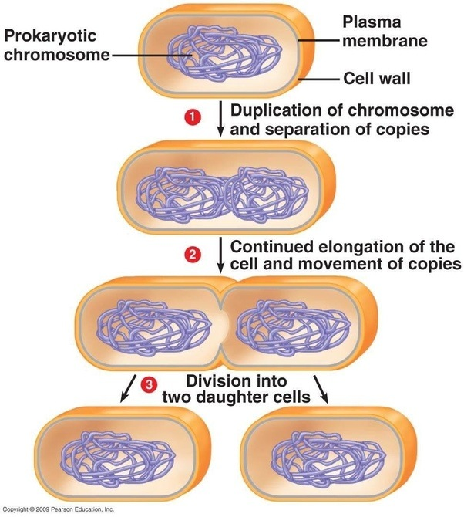
- During binary fission, the parent bacterial cell makes a copy of its large circular DNA molecule.
- The parent cell then elongates (i.e., lengthens) and the two circular chromosomes (the original and the copy) separate to opposite sides of the cell.
- After it elongates, the cell membrane pinches in, and the parent cell splits down the middle. This ensures that each daughter cell (offspring cell) receives a full copy of the genetic material (i.e., the large circle of DNA) from the original parent cell.
- Binary fission is a type of asexual reproduction. Remember, during asexual reproduction, there is one parent organism (in this case a single cell). The offspring (daughter cells) are genetically identical to each other and the original parent cell.

We will discuss sexual reproduction later. Remember, sexual reproduction involves two parents. The offspring are not identical to the parents or to each other because they each contain a different mixture of DNA from the two parents.

3. How do eukaryotes organize their DNA?
- Eukaryotic organisms can be either unicellular or multicellular.
- Examples of unicellular eukaryotes are protists and yeast (a type of fungus).
- Examples of multicellular eukaryotes are plants, animals, and most fungi.
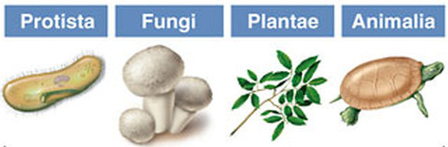

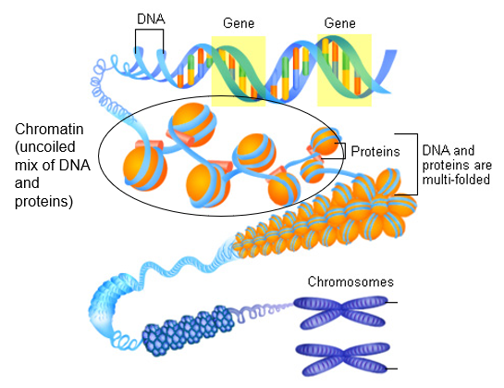

- All eukaryotic organisms contain DNA that is loosely wrapped around proteins called histones. This loose arrangement of DNA and histone proteins is called chromatin.
- Before cell division in eukaryotic cells, the parent cell copies its DNA. This is called DNA replication.

- Later, the chromatin coils up tightly into X-shaped chromosomes (they are X-shaped because they are duplicated chromosomes). The two sides of each X-shaped chromosome are identical copies of DNA called chromatids or sister chromatids. (Remember, one copy of the DNA was created during DNA replication.)
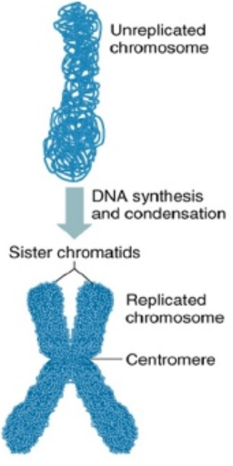
- The chromatids are connected in the middle of the X at a location called the centromere.
- When eukaryotic cells divide using a process called mitosis, the two identical chromatids in each chromosome split. The two identical chromatids end up in the two daughter cells.
- Once they are separated, the two chromatids are considered daughter chromosomes. At this point, they look like lines or rods rather than X’s. This is why the chromosomes in eukaryotic cells are often called linear chromosomes (i.e., line-shaped chromosomes). Because the daughter chromosomes no longer have an attached copy, we will call them un-replicated chromosomes (or un-duplicated chromosomes).
- When the daughter cells enter their own cell cycles, the un-replicated chromosomes will go through DNA replication to form a second chromatid. At this point, the chromosomes look like X’s again and can be called replicated chromosomes (or duplicated chromosomes).

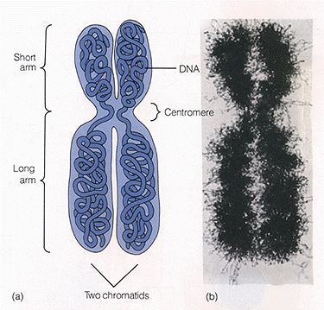
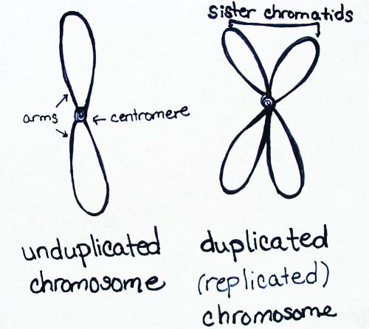

- All eukaryotic organisms have multiple linear chromosome in their cells. However, various species have different numbers of chromosomes in each cell (see chart below).
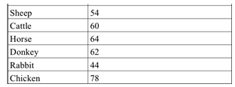
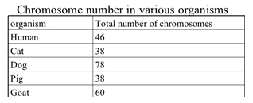

- Normal human body cells (ex: bone cells, blood cells, muscle cells, skin cells) have 46 chromosomes. Body cells are also referred to as somatic cells.

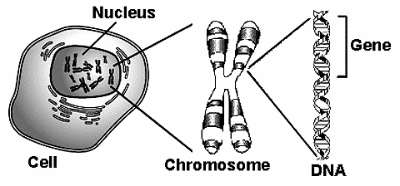
- Short sections of DNA on each chromosome that code for particular traits (ex: eye color, hair color, height) are called genes.

- The 46 chromosomes in human cells are arranged in pairs called homologous chromosomes. There are 23 pairs of homologous chromosomes in human cells.

- Homologous chromosomes have the same types of genes in the same places. For example, each chromosome within a pair may have a gene for eye color, though one chromosome may contain a blue eye gene, and the other chromosome may contain a brown eye gene.

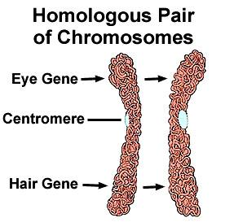
The image below shows two un-replicated homologous chromosomes with genes for eye color and hair color in the same locations. These matching locations where specific genes are found is called a locus (plural = loci).

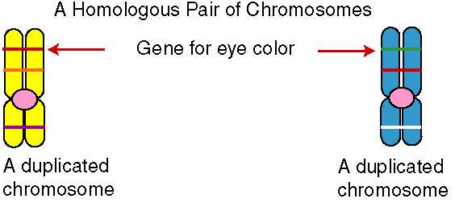
The image below shows two replicated homologous chromosomes with the gene for eye color at the same locus.

- Suppose we were talking about the homologous chromosomes in one of Albert’s cells (a random person that I just made up). One chromosome in each pair came from Albert’s father, and one chromosome in each pair came from Albert’s mother. Therefore, 23 of Albert’s 46 chromosomes came from his father, and 23 came from his mother.

The image below shows two un-replicated homologous chromosomes (aka homologues). One of these chromosomes is labeled “paternal” because it came from the person’s father. One of the chromosomes is labeled “maternal” because it came from the person’s mother.
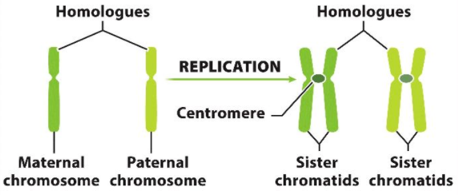
- Scientists can take a photograph of all the chromosomes in a human cell. They can then cut, rearrange, and paste the chromosomes from the photograph to create an image of the chromosomes organized in homologous pairs. This image is called a karyotype.

The karyotype below shows 23 pairs of un-replicated chromosomes from a human man.
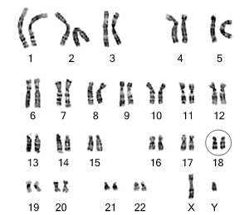
‘

having both an X and a Y sex chromosome makes a human biologically male.

The karyotype below shows 23 pairs of replicated chromosomes from a human man. (Notice that each chromosome within a homologous pair looks like an X.)

Note: I don’t think this is a real karyotype. This is just a drawing.

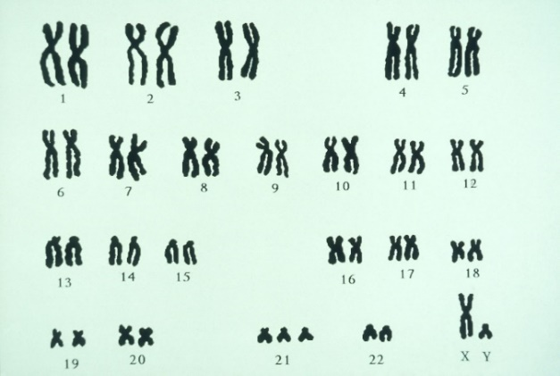

- The first 22 pairs of chromosomes in a human cell are called autosomes. These chromosomes contain genes that control traits found in both males and females (ex: eye color).

- The 23rd pair of chromosomes are called the sex chromosomes. These chromosomes contain genes that determine the different traits between males and females.

- There are two types of sex chromosomes—X and Y chromosomes.
- You can tell the difference between X and Y chromosomes in a karyotype because the Y chromosome is much shorter than the X chromosome.
- Because it is shorter, the Y chromosome contains far fewer genes than the X chromosome.
- Human females have two X chromosomes (XX), and human males have one X chromosome and one Y chromosome (XY).

4. What is the purpose of cell division in eukaryotes?
- Unicellular eukaryotic organisms use mitosis (the particular type of cell division mentioned in 3F) to reproduce asexually.

- Some multicellular organisms use mitosis to reproduce asexually as well, though this is less common.
- For example, organisms called hydra (which are closely related to jellyfish) use mitosis to create cells that form a little bud.
- This little bud eventually pops off (detaches) from the parent hydra.
- The bud then sits in the sand and grows into an adult hydra that is a clone of the original parent hydra.
- This process is called budding.

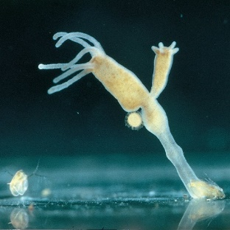
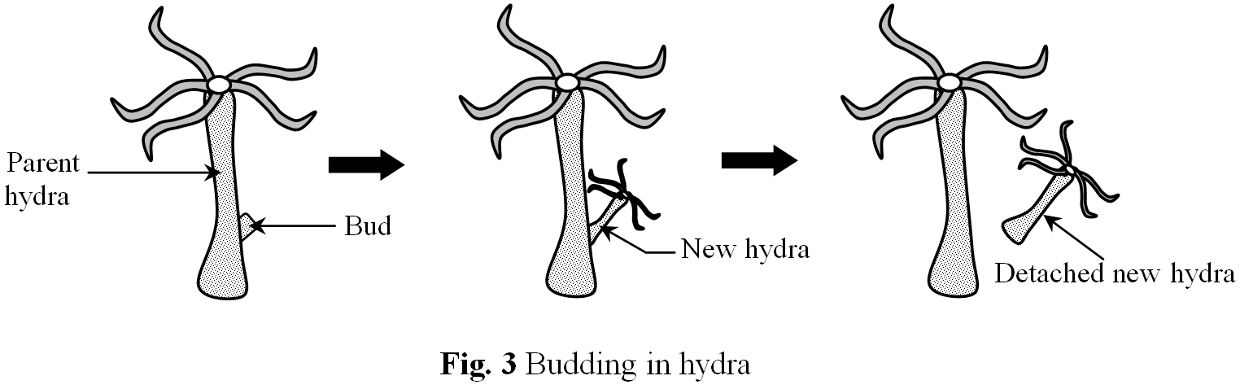

- Multicellular organisms also use mitosis to create new cells for other purposes (listed below).
- They need to create new cells for growth.
- They need to create new cells to replace cells that are damaged/dead due to injury or normal wear-and-tear.

- Most multicellular organisms use sexual reproduction rather than asexual reproduction. With sexual reproduction, there are two parents. The offspring are not genetically identical to each other or to either parent because they have a combination of DNA from both parents.

- In sexual reproduction in humans, a sperm cell (male sex cell) combines with an egg cell (female sex cell) in a process called fertilization. Together, they make a fertilized egg, a single cell which is also called a zygote. This is the first cell in the developing embryo.
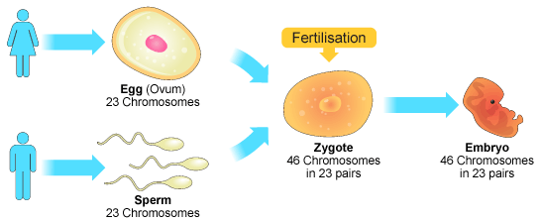

- For the baby’s first cell to have the correct number of chromosomes (46), the sperm and egg cell must have half the number of chromosomes of a normal human body cell. As such, the sperm and egg cell each have 23 chromosomes.

- To create sex cells with half the number of chromosomes in a normal body cell, organisms must use a different type of cell division—meiosis (more about this in the next topic).
- Meiosis occurs in the testes of human males to produce sperm cells.
- Meiosis occurs in the ovaries of human females to produce egg cells.

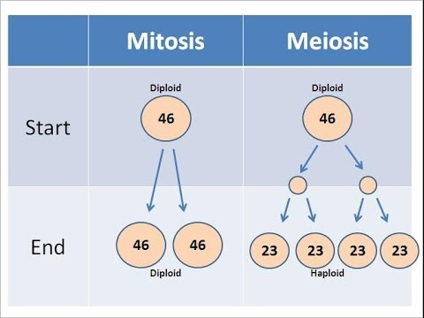
- Normal body cells (ex: blood cells, skin cells, bone cells) are also called somatic cells. They are often described as diploid cells (abbreviated as “2n”) because they have two sets of chromosomes (remember “di” means “two”). In humans, somatic cells have two sets of 23 chromosomes (one set from each parent).

- Sex cells (i.e., eggs and sperm) are also called gametes. They are often described as haploid cells (abbreviated as “n”) because they have one set of chromosomes. Remember, in humans, gametes have one set of 23 chromosomes.

- In summary, mitosis is used to create new diploid cells.
- In summary, meiosis is used to create new haploid cells.

5. Why do normal body cells in multicellular organisms divide once they grow to a certain size?
- Multicellular organisms like plants and animals are made of many tiny cells, rather than a few large cells. In fact, we humans have trillions of cells in our bodies.
- The question remains… when we grow, why don’t we simply keep increasing the size of our existing cells? Why do our existing cells divide to create new cells?
- There are two main reasons why our cells must divide rather than continue to grow once they reach a certain size. They are explained on the next page.

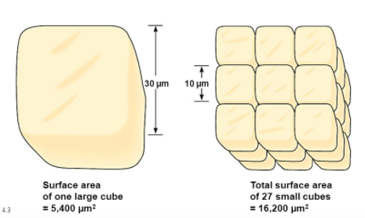
- There is not enough DNA. – As the cell increases in size, it keeps the same amount of DNA. Eventually the cell will grow too much for the DNA to control all of its activities. This is called DNA overload.

- There is not enough membrane. – As the cell increases in size, its surface area does not increase as quickly as its volume. We calculated the surface area to volume ratios of cube and sphere shaped cells of various sizes in Unit 4 (Cell Structure and Transport).
- Therefore, small cells can transport materials across their cell membranes more efficiently than large cells because they have more membrane (SA) compared to their volume.
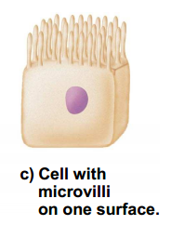
- In addition to cell size, the shape of a cell also affects its surface area to volume ratio and therefore its ability to transport materials efficiently across its membrane.
- Typically, long and thin cells have a high surface area to volume ratio.
- Cells in the small intestine have folds called microvilli. These folds help maximize the surface area to volume ratio of the small intestinal cells. This helps the small intestine cells to better perform their function. These cells are used to absorb and transport digested nutrients from food to the bloodstream. Having many membrane folds allows these nutrients to be transported through the small intestine cells towards the blood vessels more efficiently.
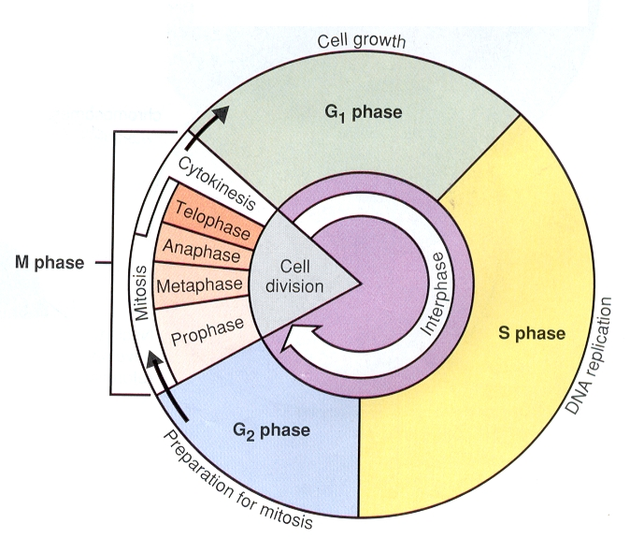
6. What are the major events in the life of a cell?
- The series of events that cells go through as they grow and divide is called the cell cycle.

- The cell cycle does not end with the death of the cell. A cell can die at any point in the cell cycle. This cell death may be caused by external factors or internal signals.

- The cell cycle ends with the division of the cell to create two daughter cells. These daughter cells then enter their own cell cycles.

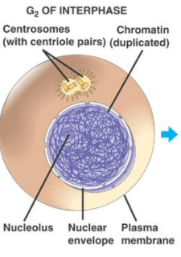
- The cell spends the majority of the cell cycle in a stage called interphase. Interphase can be defined loosely as the normal life of the cell. Interphase consists of three stages—G1, S, and G2.
- G1 (first gap) – During this stage, the cell grows and goes about its normal activities (makes proteins and
- S (synthesis of DNA) – During this stage, the cell replicates its DNA in preparation for cell division so that each daughter cell will have a full genome. The “S” stands for “synthesis,” which means “to make or create.” In this case, the cell is making a copy of its DNA.
- G2 (second gap) – During this stage, the cell prepares for division by growing, making proteins, and making additional organelles. The cell makes additional organelles so that each daughter cell will have enough organelles to perform necessary life functions.

- After interphase, the cell divides. Cell division may also be called the M phase. Cell division occurs in two parts—mitosis and cytokinesis.
- Mitosis is the division of the cell’s nucleus and DNA.
- Cytokinesis is the division of the cell’s cytoplasm and the separation of the organelles into the two daughter cells.
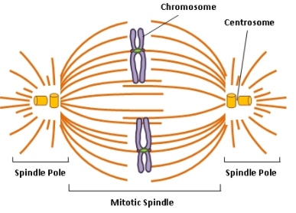
- During mitosis, a structure called the mitotic spindle (or just spindle) is used to separate the two chromatids of each X-shaped chromosome. The spindle is assembled from cytoskeletal fibers called microtubules (chains of tubulin proteins). The spindle fibers elongate by adding more tubulin subunits.

- During cell division, these microtubules (spindle fibers) grow from two structures in the cell called centrosomes. Within animal cells, centrosomes contain two cylindrical structures called centrioles, which look like churros. Scientists believe that the centrioles play some role in animal cell division, though they are not sure exactly what that role is.

- The spindle fibers attach to the chromosomes at their centromeres. Specifically, spindle fibers attach to kinetochores, which are protein structures that form in the centromere region of each chromatid during cell division.

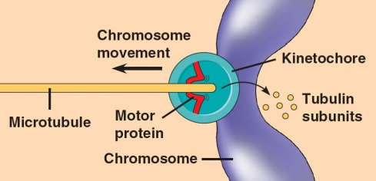
- There are two possible mechanisms to explain how spindle fibers shorten to split sister chromatids and pull them to opposite ends of the dividing cell (given below)
- The microtubules shorten at the poles (i.e. ends) of the dividing cell.
- The microtubules shorten at the end holding the chromosome as motor proteins on the kinetochore “walk” chromosomes along microtubules toward the poles / ends of the cell (see image to the right).

- Mitosis consists of four stages—prophase, metaphase, anaphase, and telophase. These stages are summarized in the chart below.
Stage | Description | Image
Prophase | In this stage, the following events occur…  - The chromatin coils up into chromosomes.  - The nuclear membrane and nucleolus break down, and we can no longer see them.  - The two centrosomes move (migrate) to opposite ends of the cell, and mitotic spindle fibers begin to grow from these centrosomes. This is the formation of the mitotic spindle.  Note: An aster is a centrosome with the microtubules of the mitotic spindle growing from it like a star.  Memory Trick: “Pro” means “before”, like prokaryote means “before the nucleus.” So prophase has to happen before anything else can happen in mitosis. | 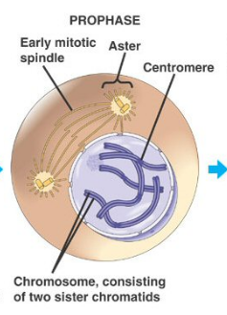
Metaphase | - Longest phase of mitosis  - Spindle fibers attach to the chromosomes and move them to form a single-file line at the center of the cell. This line is known as the metaphase plate, equatorial plate, or equatorial plane.  Memory Trick: Metaphase starts with an M so this helps us remember that during metaphase, the chromosomes line up in the Middle. | 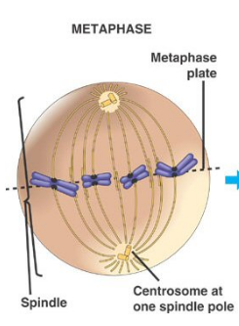
Anaphase | - Shortest phase of mitosis  - The two sister chromatids that make up each chromosome split. The spindle fibers contract to pull these chromatids to opposite ends (poles) of the dividing cell.  - Other spindle fibers lengthen and elongate the cell, preparing for cytokinesis.  - Once the chromatids have split, they are considered daughter chromosomes.  Memory Trick: Anaphase starts with an A, and that helps us remember that during Anaphase, sister chromatids are moving Apart or Away from each other. | 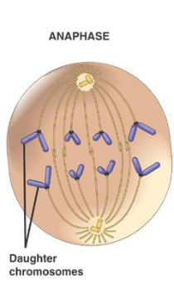
Telophase | - The daughter chromosomes reach the opposite poles of the dividing cell.  - The mitotic spindle breaks down (centrosomes/spindle fibers disappear).  - Two nuclear membranes reform around the chromosomes. Two nucleoli reform as well.  - The chromosomes uncoil into chromatin. | 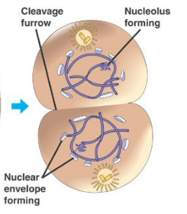

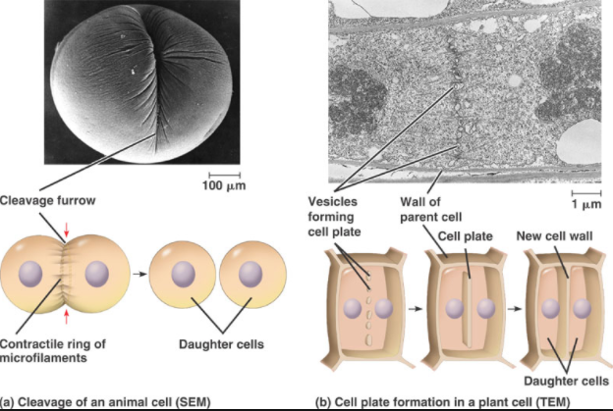
- During late telophase, cytokinesis begins. Remember, cytokinesis is the division of the cell’s cytoplasm and the separation of the organelles into the two daughter cells.
- Cytokinesis occurs differently in animal and plant cells.
- In animal cells, the cell membrane pinches in the middle, which forms a groove called the cleavage furrow. (to cleave = to split)
- In plant cells, vesicles from the Golgi apparatus carrying new cell membrane and cell wall materials line up along the middle of the cell and fuse together. This creates a cell plate that divides the two daughter cells.

- The following chart summarizes the purpose and products of mitosis.
Purpose of Mitosis in Unicellular Eukaryotes | Asexual reproduction
Purpose of Mitosis in Multicellular Eukaryotes | -Growth  -Tissue repair (replacement of dead or damaged cells)  -Asexual reproduction (only in some organisms)
Starts With | One diploid (2n) parent cell. In humans, this cell contains 46 replicated chromosomes. (These chromosomes look like X’s.)  In humans, this parent cell is a normal body cell (aka somatic cell) like a blood cell, bone cell, muscle cell, skin cell, etc.
Ends With | Two diploid daughter cells. In humans, these daughter cells each contain 46 un-replicated chromosomes. (These chromosomes look like single lines or rods.)  In humans, these daughter cells are somatic cells like blood cells, bone cells, muscle cells, skin cells, etc.
**Overall diagram of mitosis found on the next page!**
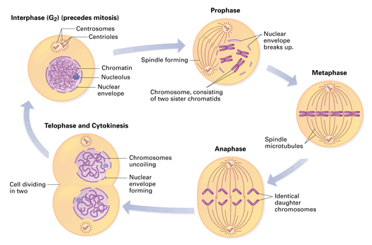

- Which types of cells in the human body normally have high rates of cell division? Why?

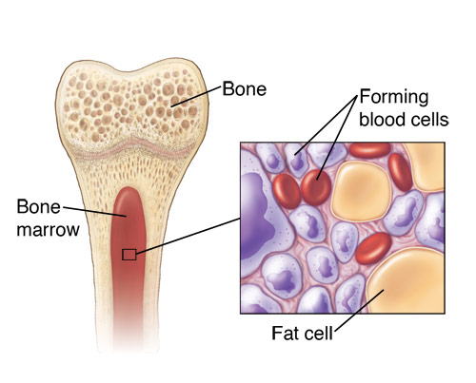
- Skin cells, cells that line the digestive tract, and red blood cells are examples of human body cells that normally have fast cell cycles. This means they have high rates of cell division. In other words, these cells tend to divide more frequently than other types of human body cells.
- These cells have high rates of cell division because they need to be replaced frequently due to damage or short life spans.
- For example, the average red blood cell lives only about 120 days. There are about 2.5 trillion of them in an adult body. To maintain this number, about 2.5 million new red blood cells must be produced each second by the division of stem cells in the red bone marrow.
- All told, about 2 trillion cell divisions occur in an adult human every 24 hours; about 25 million a second!

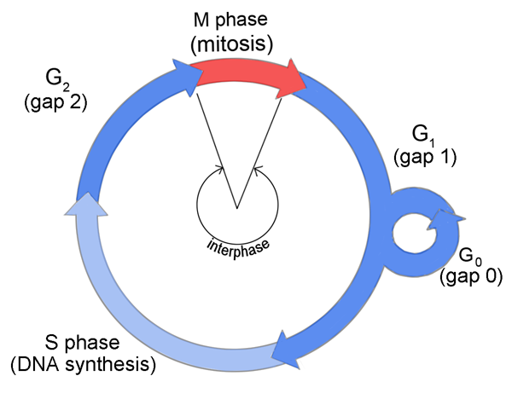
- What is the G0 state?

- Some cells exit the cell cycle during the G1 stage of interphase and enter a non-dividing state called the G0 state. This can be temporary or permanent.
- For example…
- Once you reach age 25, your brain is finished growing. At this point, the nerve cells in your brain enter the G0 state and stop dividing permanently. Even if there is damage to the brain, these cells cannot divide again to repair the injury.

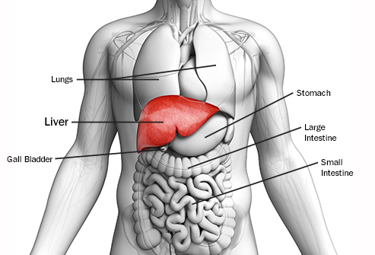
- Once your liver is finished growing, your liver cells enter the G0 state, but they can return to the normal cell cycle if there is damage to the liver. If this happens, they will divide to repair the injury.

The liver cells’ ability to leave the G0 state and divide again is the reason that a living person can donate half of his/her liver to someone who needs a liver transplant. The donor’s liver regenerates so quickly that it will be back to 90% of its original volume by 6 months post-transplant. The recipient’s liver regenerates even more quickly. It increases to over 90% of its original volume by 2 months post-transplant.

Notes Questions

- Describe the structure of eukaryotic chromatin and chromosomes. Why does eukaryotic DNA organize into chromosomes in preparation for cell division?

- During what stage of mitosis does chromatin coil into chromosomes?

- During what stage of mitosis do chromosomes uncoil into chromatin?

- Do human red blood cells and bone cells have the same number of chromosomes? Why or why not? What about sperm cells?

- What is the role of the mitotic spindle in cell division? During which stages of cell division is the mitotic spindle built and broken down?

- After chromosomes attach to the fibers of the mitotic spindle and line up at the center of the dividing cell, what happens next?

- How is cytokinesis different from mitosis? When during the cell cycle does cytokinesis take place?

- How does cytokinesis occur differently in plant vs. animal cells?

- How does mitosis produce daughter cells with the same number of chromosomes as the parent cell?

- What purposes does mitosis serve in multicellular organisms?

