Name: ___________________________________ Date: __________________________ Period: ___________

Unit 6, Part 3 Notes: Cell Cycle Regulation
AP Biology

- Why is there a need for the cell cycle to be regulated?
- The timing of the cell cycle is crucial for normal growth, development, and maintenance.
- The frequency of cell division changes depending on the cell type
  - Some divide frequently (ex: skin cells, blood cells)
  - Some can be induced to divide (ex: liver cells)
  - Some don’t divide after maturity (ex: nerve cells, muscle cells
- Chemical signals in the cytoplasm control the cell cycle
- Critical points where signals tell the cell to continue dividing or stop are called checkpoints.
- There are three major checkpoints: the G1 phase checkpoint, the G2 phase checkpoint, and the M phase checkpoint

- What happens at each of the three checkpoints?
- The G1 checkpoint occurs at the end of the G1 stage of interphase, before the cell progresses into the S stage. During the G1 checkpoint, the cell checks to see if it is growing sufficiently and contains enough nutrients to eventually divide. If not, the cell will stop progressing through the cell cycle until conditions are more favorable for growth.

During the G1 checkpoint, the cell also checks to see if its DNA is damaged. If this is the case, then the cell first tries to fix its damaged DNA. If the cell cannot repair the DNA, it destroys itself in a process called apoptosis. Apoptosis is also called programmed cell death. The image below shows the stages of apoptosis. The “apoptitic bodies,” which are essentially dead cell pieces, are then engulfed by white blood cells.
In summary: 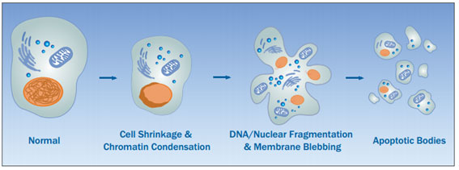
  - If a cell gets the go-ahead, it copies its DNA and divides
  - If no signal is given, the cell exits the cycle and enters a non-dividing state (the G0 phase)
  - Most human body cells are in G0, and some can return to the cycle with external cues (ex: growth factors released by injury can stimulate liver cells to divide again)

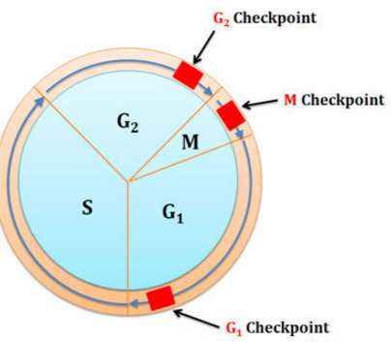
- The G2 checkpoint occurs at the end of the G2 stage of interphase before the cell enters prophase, the first stage of mitosis. During the G2 checkpoint, the cell checks to see if the DNA has been fully and correctly copied during the S stage of interphase. It also checks to see if the DNA is damaged. Again, if this is the case, the cell first tries to fix its damaged DNA. If the cell cannot repair the DNA, it undergoes apoptosis.

- The M checkpoint occurs at the end of the metaphase stage of mitosis, before the cell enters the anaphase stage of mitosis. During the M checkpoint, the cell checks to make sure that all the chromosomes are attached to spindle fibers and lined up at the center of the cell. If the chromosomes are not all correctly attached to spindle fibers, the cell pauses mitosis to allow the spindle time to “capture” the wandering chromosomes. This checkpoint helps to ensure that the two chromatids within each chromosome separate correctly into the daughter cells, resulting in 46 un-replicated chromosomes in each daughter cell.
- What are the signal molecules within cells that control progression through the cell cycle?
- Cyclin-dependent kinases are enzymes that control the cell cycle. They are present all the time in the cell, but they are typically inactive.

- These kinases are activated only when connected to cyclin proteins. This is why they are called cyclin-dependent kinases (Cdk’s). Specific Cdk’s give the go-ahead signals at the G1 and G2 checkpoints.

- As a specific example, MPF (maturation/mitosis promoting factor) is a cyclin/Cdk complex that allows cells to pass the G2 checkpoint and enter the M phase (mitotic phase).

- We do not know exactly how Cdk’s regulate the cell cycle. However, we do know that Cdk’s phosphorylate other proteins (just as all kinases do), which activates these other proteins. Cdk’s may specifically phosphorylate proteins that assist with events that begin mitosis (ex: coiling of chromosomes and creation of the mitotic spindle).

- Below is a graph that depicts how cyclin protein presence affects MPF activity (a combination of cyclin bonded to a cyclin-dependent complex). You can see that as there are more cyclin proteins in the cell, the more active MPFs are (and the faster cells will enter the cell division phase.
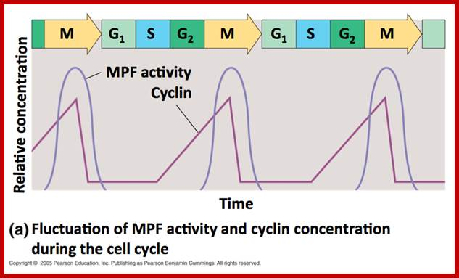

- How do cells signal to each other to initiate cell division?

- A growth factor is a protein released by one group of cells that can stimulate other cells to divide.

- Example: PDGF’s (platelet-derived growth factors) are produced by platelet blood cells. Platelet blood cells are used to clot the blood and help form a scab. PDGF secreted by platelets stimulates fibroblasts (a type of cell found in connective tissue) to divide. Fibroblasts secrete extracellular matrix materials and collagen proteins that help “knit” the skin together to continue the healing process.

- How does a cell stop dividing?

- During anaphase, MPF switches itself off by starting a process that leads to the destruction of cyclin molecules (see the circular diagram in section 3).

- Without its attached cyclin, the Cdk molecule become inactive, bringing mitosis to a close.

- How does cancer relate to cell division?
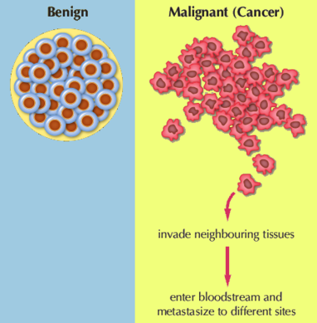
- Cancer occurs when cells divide too frequently, resulting in the formation of masses (lumps) of cells called tumors.

- There are two types of tumors—benign and malignant.

- Benign tumors do not move from the original tumor location. Benign tumors are non-cancerous.

- Malignant tumors are cancerous. Cells from malignant tumors can break off the original tumor and spread through the body using the blood vessels or lymph vessels. These cells can divide in new locations to form secondary tumors. The movement/spread of cancerous cells is called metastasis.

- Cancer cells do not display two characteristics shown by normal cells—density-dependent inhibition and anchorage dependency.
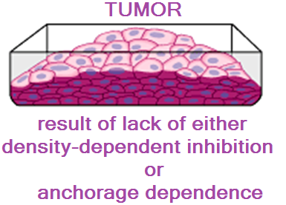
- Density-Dependent Inhibition – Normally, crowded cells stop dividing once they form a single layer.

- Anchorage Dependency – Normal cells must be attached / anchored to something to divide.

- Cancer cells do not stop dividing when growth factors are depleted. Similarly, they are not regulated by normal cell cycle checkpoints.

- Cancer cells may secrete signal molecules that cause blood vessels to grow toward the tumor. This growth of blood vessels to supply blood to the tumor and increase the risk of metastasis is called angiogenesis.

- What are some causes of cancer?

- Mutations in two types of genes can cause cancer—tumor suppressor genes and proto-oncogenes. Mutations are changes in the DNA code.

- Tumor suppressor genes normally act like the brakes of a car. They slow down the cell cycle. Some tumor suppressor genes are involved in the G1 checkpoint of the cell cycle. They prevent the cell from continuing through the cell cycle if its DNA is damaged and cause the cell to go through apoptosis if the DNA damage cannot be repaired.

A mutation in a tumor suppressor gene is like brake failure in a car. When the tumor suppressor gene does not function correctly to slow down the cell cycle, cell division rates can increase and cause the formation of a tumor.

- Proto-oncogenes normally act like the gas pedal of a car. They promote the progression of the cell cycle and prevent the cell from undergoing apoptosis. Proto-oncogenes are helpful when you get a cut and must increase rates of cell division at the location of the injury to create new, undamaged cells.

When mutations occur in proto-oncogenes, they become oncogenes. Oncogenes are also called cancer-causing genes. They stimulate cells to divide constantly, resulting in the formation of a tumor (see image on next page).

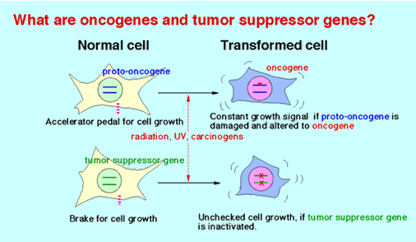

- Mutations in genes that regulate the cell cycle can be caused by a variety of substances or factors including cigarette smoke, sunlight (UV radiation), certain viruses, pollutants, etc.

- Any substance or factor that mutates DNA is called a mutagen. A mutagen that causes cancer is called a carcinogen.

- How does chemotherapy work to treat cancer?

- Chemotherapy is one possible treatment option for patients with cancer. Other possible treatment options are radiation, immunotherapy, surgery to remove tumors, etc.

- Chemotherapy drugs work by destroying quickly-dividing cells like cancer cells. Unfortunately, they also destroy cells that normally divide quickly like hair follicle cells and cells that line the digestive tract. This can result in hair loss and nausea.

Notes Questions

- Why might the G1 checkpoint be the most important in regulating the cell cycle?

- If the cell “notices” that not all the chromosomes are attached to spindle fibers, what happens? What checkpoint does this relate to?

- What is the only situation where mature liver cells will exit the G0 state?

- If cyclin cannot accumulate during interphase, how will this affect the activity of cyclin-dependent kinases?

- What types of proteins does MPF phosphorylate (i.e. activate) to initiate the beginning of mitosis?

- If PDGF’s are not released by platelet blood cells after an injury, how will this affect healing? (Use the term fibroblasts in your answer.)

- How does MPF end cell division?

- Based on the graph, how does MPF activity change as the cell moves through different phases of the cell cycle?
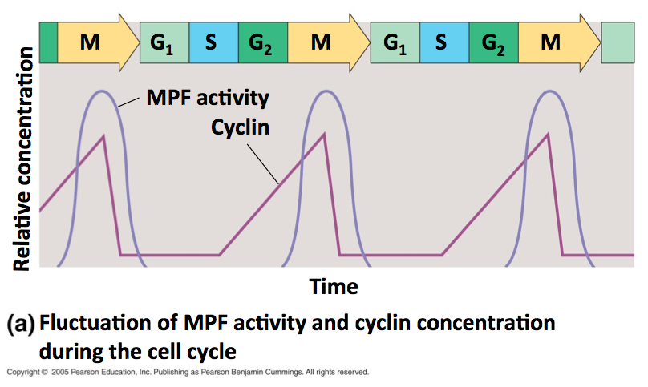

- Based on the graph, how does the cyclin concentration change as the cell moves through different phases of the cell cycle?

- Based on what you know about cyclin and MPF, explain the connection between the trends you described in 8 and 9.

- Describe two ways in which cancer cells act differently from normal cells.

- Explain how metastasis and angiogenesis relate to one another.

- How is a benign tumor different from a malignant tumor?

- What types of cells are “targeted” by chemotherapy drugs? Why do people experience hair loss during chemotherapy?

