Name: __________________________________________________ Date: _______________________ Period: ______

**Unit 7 Review Packet Molecular Genetics**

**Topic #1: DNA**

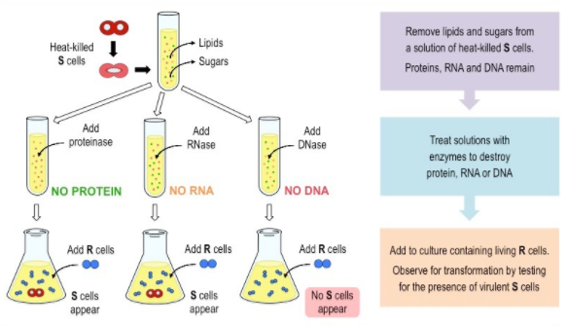1) What conclusions did Avery, McCarty, and Macleod draw from the results of their experiment, which expanded upon Griffith’s experiment?

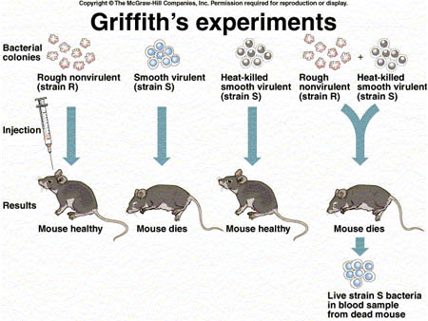

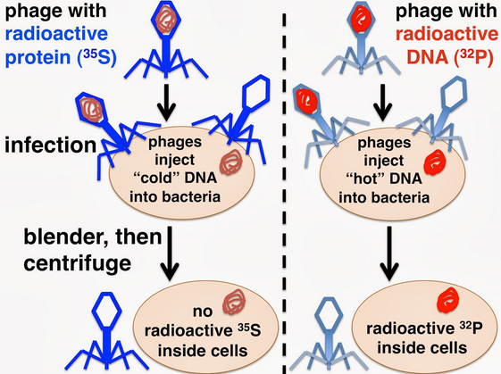2) What conclusions did Hershey and Chase draw from the results of their experiment? Which molecule was injected from the virus into the bacteria (i.e. the genetic material of the virus), and how did they know?

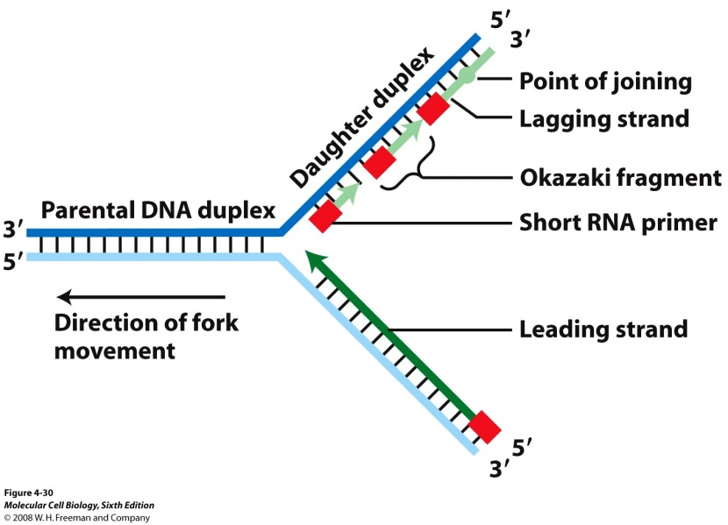3) The image to the right shows DNA replication. How will the new DNA strand be created on the top and bottom of the molecule using DNA polymerase?

1. Identify the model of DNA replication shown in each diagram below (dispersive, conservative, or semiconservative). Which model is correct? (You may need to look at the color version of these pictures!) Which one is correct?

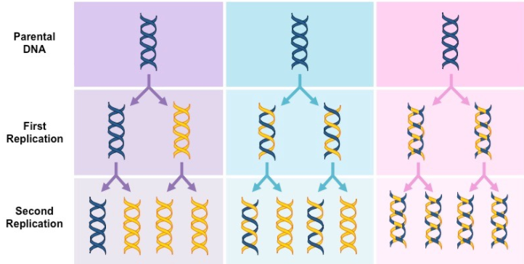

5) Guanine makes up 23% of the nucleotides in a sample of DNA from an organism. Approximately what percentage of the nucleotides in this sample will be adenine **and why**?

6) Identify the roles of the following enzymes in DNA replication: helicase, primase, DNA polymerase, and ligase.

**Topic #2: From Gene to Protein**

7) Use the following chart to compare transcription and translation:

|  |  |  |  |  |
| --- | --- | --- | --- | --- |
| **Process** | **Starting Molecule** | **Ending Molecule** | **Location in a Eukaryotic Cell** | **Helper Enzymes / Molecules Used** |
| Transcription |  |  |  |  |
| Translation |  |  |  |  |

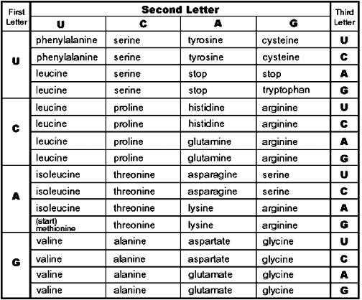

8) Some geneticists consider the third base of a codon to be less important than the first two bases as a code for a specific amino acid. Why is this the case? Provide a specific piece of evidence from the codon chart to support your explanation.

9) What is a possible mRNA sequence (written from its 5’ to 3’ end) that could produce the following amino acid sequence?

Leu – Lys – Gly – Val – Ser – Tryp

10) Using your mRNA sequence from #9, write out the DNA sequence (from 3’ to 5’) that could produce this mRNA sequence.

11) Describe the mutation that occurred in the mutated DNA sequence given below. Predict the effect on the resulting polypeptide

Original DNA: A G G T C T A A A G T G

Mutated DNA: A G G G T C T A A A G T G

1. Describe the mutation that occurred in the mutated DNA sequence given below. Predict the effect on the resulting polypeptide

Original DNA: A G G T C T A A A G T G

Mutated DNA: A G G A A A G T G

13) A cell has a defective enzyme that attaches the alanine amino acid (Ala), instead of a valine amino acid (Val), to tRNAs with the anticodon CAA. Will any polypeptides in the cell contain valine? Why or why not?

14) How is the mRNA strand altered during mRNA processing (the intermediate step between transcription and translation)? How are these modifications helpful?

**Topic #3: Viral and Bacterial Genetics**

15) What is occurring in the process shown below? Is this process beneficial or harmful to the bacterial **population**? Explain your answer.

16) How is retroviral infection different from infection by a “normal virus?” Which type of virus has a higher mutation rate and why?

17) What are the differences between the lytic and lysogenic cycles of viral reproduction?

18) Describe the difference between bacterial conjugation and transformation. What is the purpose of these processes?

***Note: For the calculations portion of the test, please study your DNA Statistics Assignment.***

(standard deviation, standard error, 95% confidence interval, and constructing error bar graphs!