Name: __________________________________________________ Date: _______________________ Period: ______

**Unit 9 (Classical Genetics) Review Packet**

AP Biology

**Topic #1: The Basics of Mendelian Genetics**

1. In garden peas, a single gene controls stem length. The recessive allele (*t*) produces short stems when homozygous. The dominant allele (*T*) produces long stems. Two heterozygous long-stemmed plants are crossed. List the expected phenotypes of the offspring as a ratio.
2. In sheep, eye color is controlled by a single gene with two alleles that display incomplete dominance. When a homozygous brown-eyed sheep is crossed with a homozygous green-eyed sheep, blue-eyed offspring are produced. If the blue-eyed sheep are mated with each other, what percent of their offspring will most likely have blue eyes?
3. In corn, the trait for tall plants *(T)* is dominant to the trait for dwarf plants *(r)* and the trait for colored kernels *(C)* is dominant to the trait for white kernels *(c).* In a particular cross of corn plants, the probability of an offspring being tall is 1/2 and the probability of a kernel being colored is 3/4. Based on these offspring phenotype frequencies, what are the possible genotypes for the parents?
4. Hemophilia is inherited as an X-linked recessive trait. If a male with hemophilia marries a normal female, and she is not a carrier…
5. What percentage of their offspring will have hemophilia?
6. What percentage of their male offspring will have hemophilia?
7. What percentage of their female offspring will have hemophilia
8. Galactosemia is a simple, inherited, autosomal recessive trait. A normal couple has a child affected with galactosemia.
9. What is the chance that both of their next two children will be normal?
10. What is the chance that their next child will have galactosemia or be a carrier for galactosemia?
11. Black fur in mice (*B*) is dominant to brown fur (*b*). Short tails (*T*) are dominant to long tails (*t*). What fraction of the progeny of crosses *BbTt* × *Bbtt* will be expected to have black fur and long tails?
12. In the cross *AaBbCc* × *AaBbCc*, what is the probability of producing the genotype *AABBCC*?

**Topic #2: Human Genetics**

1. If a child has blood type O, and his mother had blood type A, what are the possible blood types for the father?
2. Describe the relationships between the three blood type alleles—A (IA), B (IB), and O (i).



1. Hemophilia is a sex-linked recessive trait. Fill in the genotypes for all individuals on the pedigree to the right. Let Xa = the hemophilia allele, and let XA = the normal allele.
2. The ACHOO syndrome is an inherited condition that leads to sneezing in response to bright light. What evidence in the pedigree suggests that ACHOO syndrome does NOT follow an X-linked dominant pattern of inheritance?

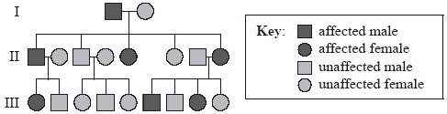

1. Explain the difference between polygenic inheritance and pleiotropy.
2. Explain why each of the following patterns of inheritance will NOT work for the pedigree shown below—X-linked dominant and x-linked recessive.

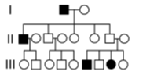

**Topic #3: Chromosomal Genetics**

|  |  |
| --- | --- |
|  | F2 Generation |
| 125 | red eyes, long wings |
| 124 | purple eyes, vestigial wings |
| 18 | purple eyes, long wings |
| 16 | red eyes, vestigial wings |
| 283 | Total |

1. A male fruit fly (*Drosophila melanogaster*) with red eyes and long wings was mated with a female with purple eyes and vestigial wings. All of the offspring in the F1 generation had red eyes and long wings. These F1 flies were test crossed with purple-eyed, vestigial-winged flies. Their offspring, the F2 generation, appeared as indicated to the right.
2. Why is there a high frequency of red eyed / long winged flies and purple eyed / vestigial winged flies?
3. How is it possible to have purple eyed / long winged flies and red eyed / vestigial winged flies?
4. What would be the distance in LMU between eye color and wing type on the fruit fly chromosome?
5. 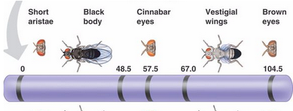Based on the linkage map given to the right, which two genes are most likely to be separated by crossing over? Why?
6. A karyotype shows the visual appearance of an individual’s chromosomes. The karyotype below shows a chromosomal abnormality.

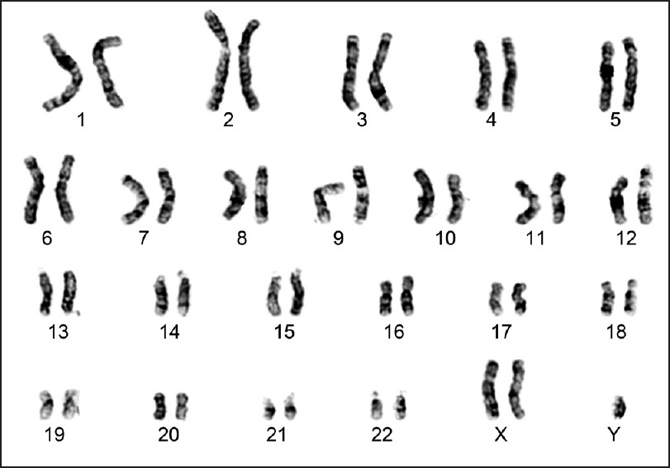

1. Explain how this type of abnormality could occur and support your claim with evidence from the karyotype.
2. Relate this abnormality to Mendel’s Law of Segregation.

**\*\*Be sure to review Chi Square Analysis and how to use it with genetics problems for the Unit Exam\*\***

**Look over your *Genetics of Indian Corn* Packet – it’s got the whole step by step process in it with examples!!**