Name: ________________________________ Unit 8
Period: _______ Page: _______
Unit 8 Notes: Evolution & Classification
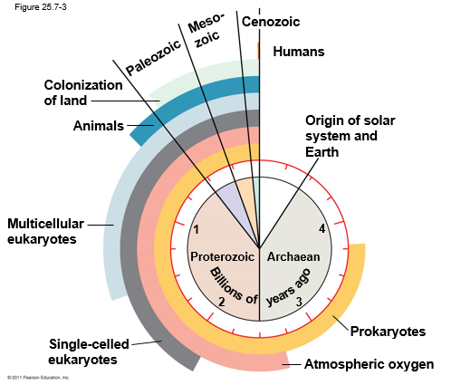
Topic 1: History of Life
By the end of this topic, I will be able to…
- Match the origin of life experiments to the person that conducted them
- Explain the various origin of life experiments
- Sequence the order of life on earth
- Explain how eukaryotic cells evolved from prokaryotic cells

- The History of Life & Origin of Life Experiments
- Earth + solar system formed about _____________________________________
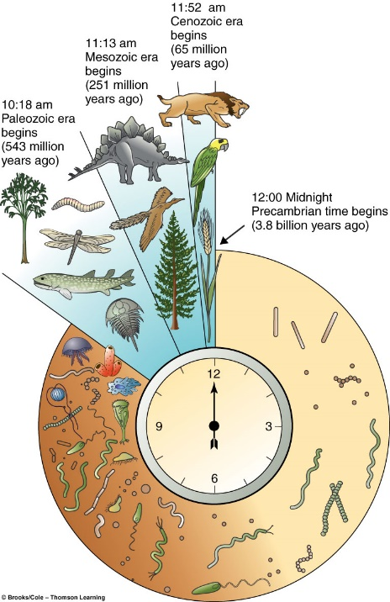
- Bombardment of Earth by rocks and ice likely vaporized water and prevented seas from forming before 4.2 to 3.9 BYA
- Earth’s early atmosphere likely contained:
- ______________________ and chemicals released by volcanic eruptions like _______________, nitrogen oxides, _______________________, methane, ammonia, hydrogen, hydrogen sulfide.
- NO ___________________________________ in atmosphere!
- ____________________ evolution occurred prior to biotic (living) evolution
  - Energy from sun, volcanoes and lightning combined w/ gases to form chemical substances (sugars, nucleotides, amino acids) which then combine to form all life on Earth

Origin of Life Experiment #1: Miller-Urey
- In the 1950s, scientists Miller & Urey set out to demonstrate that it was possible for _______________________________ to appear on earth, given the early atmospheric conditions, without organisms actually present yet
  - Recreate earth’s early atmosphere (H, CH4, NH3, H2)
  - Add electric sparks (simulate ______________________)
  - Gasses cooled, leaving ___________________________
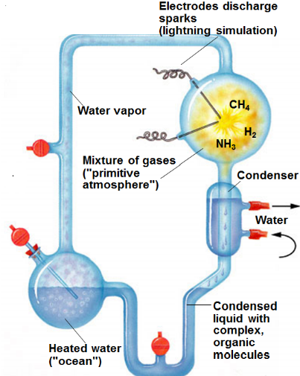
    - Water droplets contained ______________________ and ________________!
      - This meant that yes, amino acids and nucleotides could have formed under early conditions on earth!
- Bottom line: Organic molecules CAN form from inorganic molecules
- RNA evolved before DNA. Why does this make sense?
  - RNA codes ______________________ (makes inheritance possible)
  - It can __________________________________
  - First step of evolution in the Central Dogma
    - _________RNA___________________

Spontaneous Generation v. Biogenesis
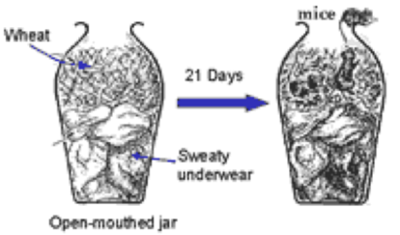  Spontaneous Generation | - Until about _______________________, many people believed life could arise from ________________ matter.  - Spontaneous Generation: belief that life can arise from nonliving things  - Frogs arise from mud  - Flies arise from rotting meat  - Mice arise from dirty underwear  - _______________ approved this belief – people trust the church, so they thought this must be right  - Francesco Redi is the first big name to say something different (__________________________)  - This led to a battle of experiments to determine how life actually comes to be
Biogenesis  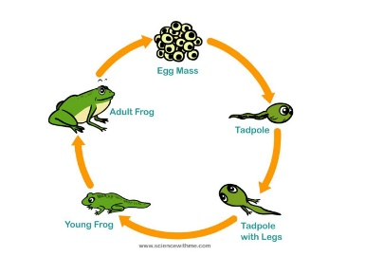 | - The belief that life can only come from __________ matter  - ________________________________________  - Now widely accepted, but was not until about _________  - In the life cycle of a frog, tadpoles hatch from eggs, eventually are frogs  - Flies were previously larvae, which hatched from eggs (deposited on the meat)  - Mice are born from other mice

Origin of Life Experiments
Francesco Redi (1668)  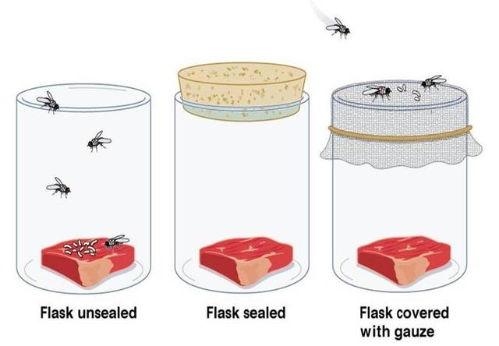 | - Designed an experiment to test spontaneous generation  - In support of: _______________  Setup: three jars, each holding meat  - Control: ____________________  - Flies and air have access to meat  - Experimental setup 1: __________ lid  - Neither flies nor air can access meat  - Experimental setup 2: _______ lid (cheesecloth)  - Flies cannot access meat, air can  Findings: the only jar with flies was the control!
John Needham (1748)  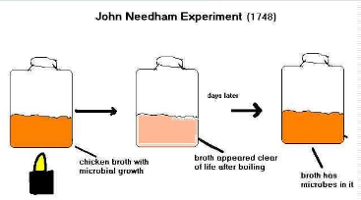 | - John Needham, an Englishman, wanted to prove Redi wrong  - In support of: _________________________  Experiment: heat broth to remove ____________; seal and let sit… check for life  Findings: there is bacteria in the broth! Spontaneous generation must be right.  Problem: did not ____________________________________ _________________________ to remove all microbes
Lazzaro Spallanzani (1770)  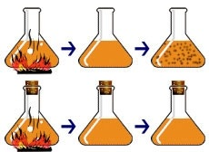 | - Lazzaro Spallanzani, an Italian doctor, was sure Needham made a mistake when attempting to remove all microbes and repeated his experiment  - In support of: _______________________  Experiment: pour broth in two flasks; heat broth (kill microbes); seal one flask and leave the other open  Findings: only the _________________ contained microbes
Louis Pasteur (1864)  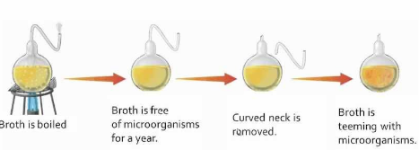 | - French scientist that ended the debate  - In support of: ___________________________  - built upon the work of Needham and Spallanzani, but with a twist.  Control: flask with broth that had been heated to kill microbes  Experimental setup: _______________________ __________ with broth heated to kill microbes  - Air has access to the broth!  Findings: swan-neck flask remained microbe-free until tilting the flask, allowing the broth to pick up microbes from the bend… spontaneous generation is not real!

- Sequencing Life on Earth
- Earth: 4.6 billion years old
Relative Dating  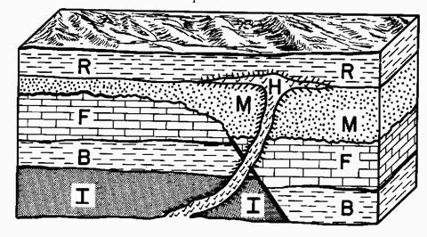  Oldest to youngest: _________________________ | - _____________________ age based on the position in the ____________ of the sedimentary rock  - _____________ form when fine sediment buries organisms, but if they are not buried, it is possible to decay before fossilizing  - Areas with wet lowlands or slow moving water are excellent for fossil formation
Absolute (Radioactive) Dating  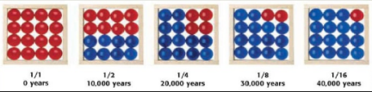 | - ____________________ based on ________________ of remaining fossil using radioactive dating (carbon-14)  - Half-life: amount of time it takes for ½ of the radioisotope to decay  - Remember: isotopes are the same ____________ with different numbers of __________________  - Carbon Dating: You want to determine how long it is taking for half of the sample of the isotope to decay.
- Method of aging: radioactive/absolute dating v. relative dating
- Early atmosphere: CO2, SO2, Methane, ammonia… no free O2
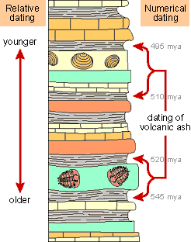
  - RNA and amino acids form and lead to first cells

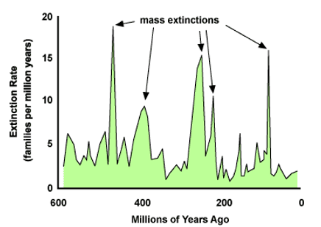
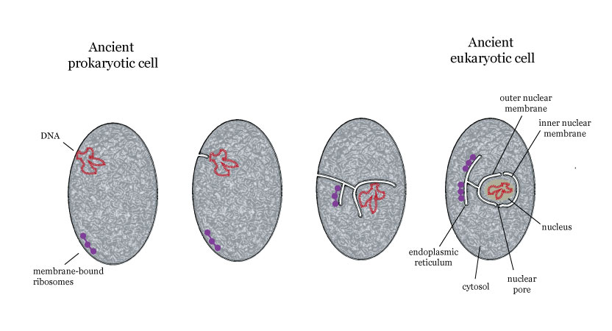
- Precambrian Era (3.5 billion years ago- oldest life)
- Prokaryotes
- Atmosphere lacked ________ _____________
  - Organisms had to be _________________________
- First cells were archaebacteria (_______________________)
  - Cell walls lack peptidoglycan
  - Methanogens, halophiles, thermophiles
- First cells were ____________________________
  - There were autotrophic archaebacteria (chemosynthesis, not photosynthesis)
    - As autotrophs began living, they put oxygen into the environment (produce ozone layer)
    - Oxygen began accumulating 2.7 BYA (banded iron/rust in rocks)
- Blue green algae, ______________________________________, were the first photosynthetic organisms
  - Produce: __________________ which is a carbohydrate (and ________________)
  - Require: __________________________________
  - Significant oxygen in the atmosphere ___________________________________ years ago

- Eukaryotes Evolve (2.7 BYA)
- ______________, more _______________________ than prokaryotes
  - Can reproduce sexually, increasing ______________________________________________
- Contain a nucleus and other membrane-bound organelles (golgi, lysosomes) for specific jobs in the cell
  - Internal membranes increase ____________________________
- How eukaryotic cells evolved: ___________________________
  - Ancestral cell _________________ a smaller cell (___________________ bacteria or ___________________________________ bacteria), but did not _____________________________
  - Origin of the ____________________ and _________________________
  - Mitochondria and chloroplast contain their own (circular) _____; have bacterial shape/structure
  - Formed a ____________________________________________________ relationship

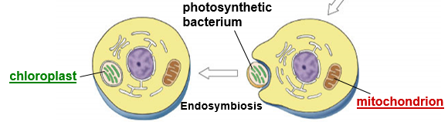

- Paleozoic Era (245-542 MYA)
- The first ___________________________________________________________ organisms evolve: _________!
  - Fish are vertebrate (have a _________________________)
- First plants evolve from seaweed and over many generations, some species evolve and move to land
- Traces of complex burrows have been found meaning that ___________________________________________
- Dominant animal life: ______________________________________
  - Vertebrate that spends half its life in the water, the other half on land
  - Certain fish evolved limbs and lungs for land life around 380 MYA
- Conifer evolves (a type of plant that has cones for seeds)
  - Better adapted to drier climates
  - Flowering plants not yet established (all other major plant groups are)
- Mass extinction to close this period ended ________________________________________________ on earth

- Mesozoic Era (65-245 MYA)
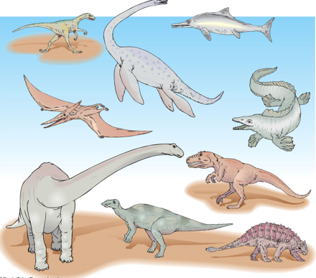
- ________________________ breaks and ______________________________ begin forming
- _____________________ begin to dominate
- _______________________________ roamed in this period
  - First 150 MY of period is ruled by dinosaurs
- Birds evolve from __________________________ about 155 MYA
- Mammals evolve at the same time as dinosaurs, but do not dominate
  - Many were very small, nocturnal insect eaters
    - Nocturnal: ___________________________ ___________________ (warm-blooded)
- Flowering plants and insects ________________________
  - When two organisms evolve at the same rate, same time, most often because of each other.
- Leafy trees and shrubs also evolve

- Cenozoic Era (present/current)
- Comparatively short when compared to other eras, but full of fossils! (deep record)
- ___________________________________ replace reptiles as the dominating group
  - Mammals: fur, fat, mammary glands, vertebrates
  - Angiosperm dominance (_____________________________________) influenced faster evolution of birds and mammals
- ~35 MYA– climate became cooler/drier
  - Remember, mammals are warm-blooded
- ~2 MYA, _______________________ evolved
  - Use of fire
  - Society and culture
  - Tools to control world

Topic 2: Evolution
By the end of this topic, I will be able to…
- Compare and contrast the theories of Darwin and Lamarck
- Explain the evidence for and of evolution
- Describe the process of speciation

- Key Vocabulary:
- Inference: interpretation based on _________________________________________________________
- Hypothesis: a scientific explanation that can be ______________ (research based, written ______________)
- Theory: a well-tested explanation that unifies a ________________________ of observations and hypotheses
  - About the ___________________________
  - Lots of _________________________ in support
- Law: a statement based on repeated experimental observations
  - ________________________________________________________________________________
- Evolution is a __________________ in a _________________________ [of species] over a period of time
  - Genotypic v. phenotypic changes
- Evolution acts on populations, not __________________________
  - A population is a group of individuals of the same species in an area (can interbreed)
- Populations share a ____________________________
  - Gene pool: all of the genes (____________________) for all of the traits in a given population at any time
  - If all members of a population are homozygous for a particular allele, then the allele is ______________ in the gene pool
- Microevolution: _______________ scale (molecular)
  - Seen in __________________ populations
- Macroevolution: ________________ scale (speciation)
  - Seen in the _____________________ record

- Scientists
Jean Baptiste Lamarck (1744-1829) | Acquired Traits  - Theory of _______________________________  - If an organ is used, it becomes stronger and better developed  - If an organ is not used, it becomes weaker and withers away  - Believed an organism acquires traits based on ___________________________________________, not from genes  - This is WRONG
Charles Darwin (1809-1882) | Natural Selection  Descent by Modification  - Nature will select the organisms that have ___________________ that allow them to better _________________ and ________________________ (survival of the fittest)  - Found that species vary locally/globally/over time  - Studied finches and other animals in the Galapagos while on board the HMS Beagle (naturalist on voyage)

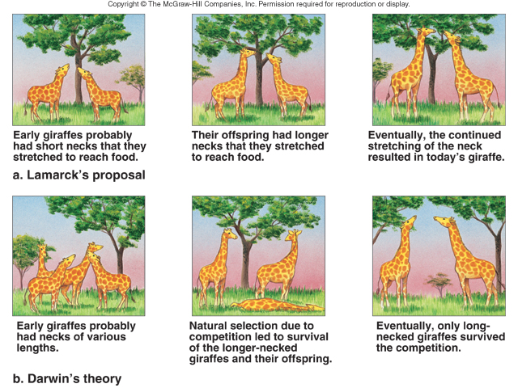

- Natural Selection
- There is _______________________________________ in every population
- Some variations are __________________________ (these organisms live and can reproduce, the others die)
- More young are produced in each generation than can survive (_______________________________)
- There is _____________________________ for resources (food, water, shelter, space) (struggle for existence)
- Those that are successful go on to reproduce
- Overtime, small changes accumulate in a population because the best traits continue to be passed on
- What leads to these changes?
  - Random _______________________________________________
    - Organisms w/ shorter generation times have higher mutation rates & so evolve quicker than animals w/ longer generation times
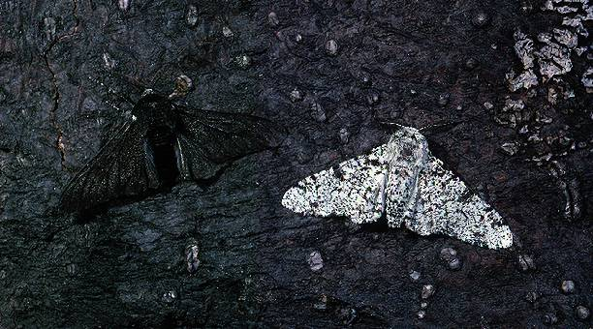
Examples:
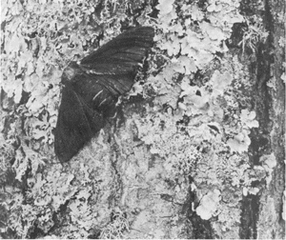
- Industrial Revolution vs. Peppered Moth
  - Explain: _________________________________________________ ________________________________________________________ ________________________________________________________ ________________________________________________________
________________________________________________________
________________________________________________________
________________________________________________________
________________________________________________________
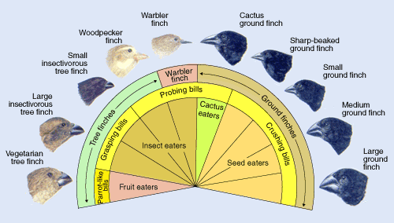
- Darwin’s Finches
  - Explain: ________________________________ ________________________________ ________________________________ ________________________________ ________________________________
________________________________ ________________________________ _______________________________________________________________________________________
_______________________________________________________________________________________

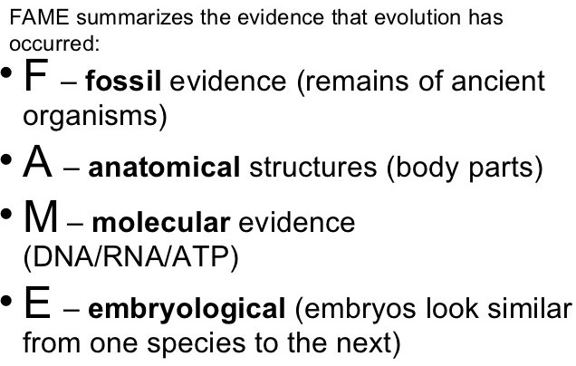
- Evidence of Evolution
- Fossils
  - Trace of long-dead organism found in layers of ________________________________ rock; ______________ ____________________________________
- Comparative anatomy
  - Compare _________________ in modern organisms with ancient organisms (homologous, analogous, and vestigial structures)
- Comparative embryology
  - Finding similarities in embryos; organisms with a ___________________________________________ ______________________________________________
- Comparative biochemistry
  - Finding similarities in protein and DNA sequences (the ________________________ differences, the _________________________ related two organisms are)

- Fossils
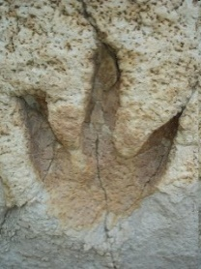
(tell us age, diet, habitat, lifestyle)
Types of Fossils
- Mold = __________________ in rock
- Cast = a __________________ filled with _______________________
- Trace Fossils = ________________________________________ (footprints, burrowing, etc.)
- Resin Fossils = organisms that have been _____________________ nearly perfectly in plant resin (amber)
- “Living Fossils” = any living species that is ______________________________ to species previously known only from fossils

- Comparative Anatomy
Anatomy: HOMOLOGOUS Structures
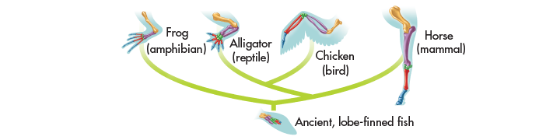
- Darwin proposed that animals with similar structures evolved from a ____________________________ with a basic version of that structure.
- Structures that are shared by _________________________________ and that have been inherited from a common ancestor are called homologous structures.
- Homologous structures are similar in structure because they develop from same __________________ early in development
  - may or may not have different functions.

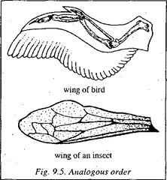
Anatomy: ANALOGOUS Structures
- The clue to common descent is common structure, NOT common ___________________. A bird’s wing and a horse’s front limb have different functions but similar structures/bone configuration (homologous structures).
- Body parts that share a common function, but NOT structure, are called analogous structures. Analogous structures are used for the same purpose but are ____________________________________ ______________________________________________________. The wing of a bee and the wing of a bird are analogous structures.

Anatomy: Vestigial Structures
- Not all homologous structures have important functions.
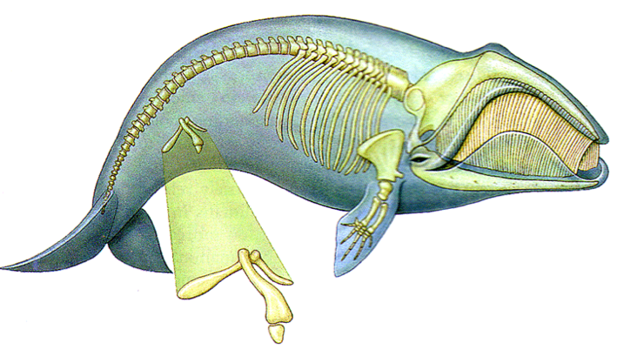
- Vestigial structures are ___________________________________________ from ancestors, but have lost much or all of their ______________________ function due to different selection pressures acting on the descendant.
  - The hipbones of bottlenose dolphins or any whale are vestigial structures. In their ancestors, hipbones played a role in terrestrial locomotion. However, as the dolphin or whale lineage adapted to life at sea, this function was lost.
  - The human tailbone and appendix are vestigial structures.
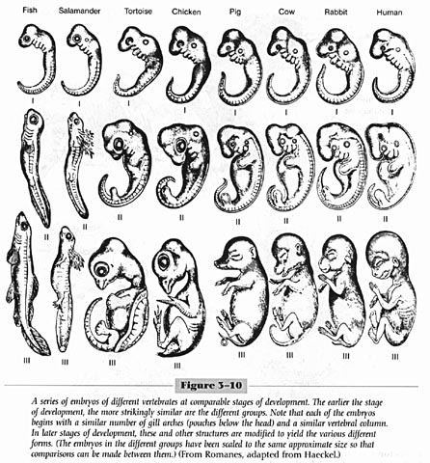
- Comparative Embryology
- Explain the image to the right in your own words:
_____________________________________________________
_____________________________________________________
_____________________________________________________
_____________________________________________________
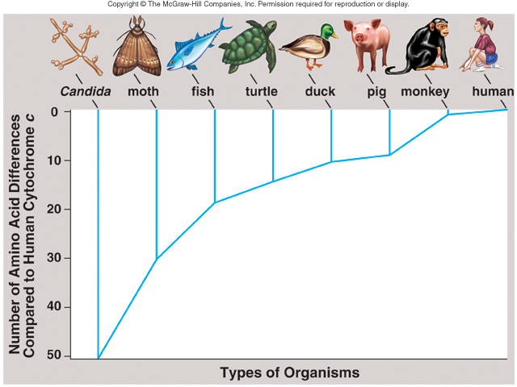
- Comparative Biochemistry
- Universal ____________________________ – organisms use the same triplet code (codons) and the same 20 amino acids to build all proteins
- All organisms have certain organic molecules in common.
  - Hemoglobin - carries oxygen in blood
  - Cytochrome c - protein for cell respiration found in almost all living cells (see graph)
  - HOX genes – control development

- Types of Natural Selection
- Stabilizing
- Directional
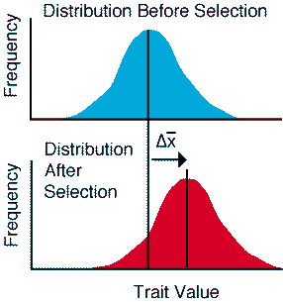
- Disruptive (AKA diversifying)
- Sexual

Directional Selection: Individuals at one ________ of the curve (those who have an “extreme” trait in one direction) have higher fitness than those in the middle or at the other end. Over __________ _____________________, the variation of the population’s traits will shift in that direction.
  - Examples: Largest beak size in finches, or longest necks in giraffes are favored in a particular environment.

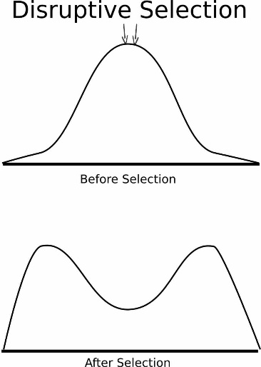
Disruptive Selection: Individuals at both __________ of the curve have higher fitness than those near the middle (the extreme traits are more favorable over the intermediate trait)
  - Creates two different ____________________________________ .
  - Examples: In mice that are brown, white, and tan, the brown and white mice are more often chosen as mates because they ______________________ in coloration. The tan intermediate color is not chosen as often, as thus is not favored by the “environment” (the female mice).

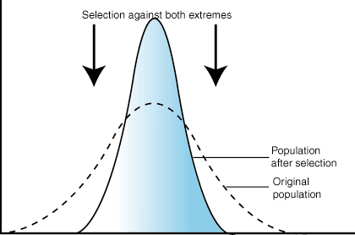
Stabilizing Selection: Individuals near the _________________ of the curve (with an “intermediate” trait) have higher fitness / stronger advantage than those at either end of the curve.
  - This usually occurs in a very stable environment
  - Example: Out of black, tan, and white beetles that live in the desert, the intermediate trait (TAN) would be favored by the environment since they would ____________________________ _________ and be harder for predators to see.
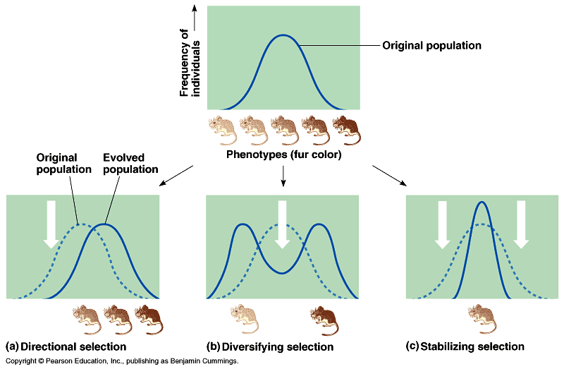

Which type of selection could lead to one species splitting up into 2 separate species? ________________________________________
Why?
____________________________________________ ____________________________________________ ____________________________________________

Sexual Selection: Females choose males based on _______________ _______________.
- Males with these traits have higher fitness, meaning they reproduce more and pass on their traits to offspring
  - “Reproductive success”
  - Examples: Female gorillas choose male gorillas as mates based on their __________ and peahens (female peacocks) choose their mate based on their _________ _____________________.

Artificial Selection:
- To find an explanation for change in nature, Darwin studied change produced by plant and animal breeders.
- Breeders knew that individual organisms vary, and that some of this variation could be passed from parents to offspring and used to improve crops and livestock – ____________________________________________.
  - For example, farmers would select for breeding only trees that produced the __________________ _____________ or cows that produced the ____________ ______________.
- Over time, this selective breeding would produce trees with even bigger fruit and cows that gave even more milk.
- Artificial Selection = humans “__________________” certain characteristics in plants, dogs, etc., that they find favorable

- Speciation
First off, how do we define a species? Not all scientists agree!
- Morphological Species Concept – ___________________ and ______________________ structures are used to group organisms into species
- Biological Species Concept– defines a species as a population of organisms that can successfully ___________________________________
- Speciation = formation of a __________ ______________________

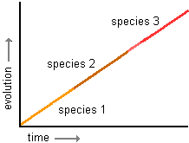
Reasons for Speciation
1) ________________________ Isolation
2) ________________________ Isolation
-prezygotic (before fertilization)
-postzygotic (after fertilization)

Two Models of Speciation

- Model #1: Gradualism: change happens _____________________, and new species are made at a _______________________________________________
    - See the graph on top
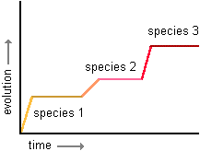
- Model #2: Punctuated Equilibrium: there are times of little or no change followed by times of _____________ ________________ – often due to major changes in the environment
    - Stephen Jay Gould came up with this model!
    - See the graph on the bottom

- Patterns of Evolution:
- Co-evolution: change of two or more _______________ in response to one another (they evolve together over time)
- Convergent: organisms with _____________________ ancestors become very ___________________ due to environment (they become more alike)
- Divergent: two or more ____________________ populations/species become ________________________
  - Adaptive Radiation: an ____________________ form of ________________________ evolution where many related species evolve from a single ancestor species (Darwin’s finches)

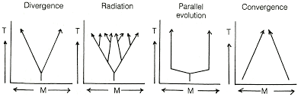

Topic 3: Classification
By the end of this topic, I will be able to…
- Name the three domains and describe common characteristics for each
- Identify the kingdom an organism belongs to when provided characteristics
- Interpret a cladogram
- Use a dichotomous key to name an organism

- What is Classification?
- Definition: putting organisms into groups based on their _______________________________.
- How? – Using _________________________________________________. When comparing the anatomies of different organisms, researchers look at:
  - Homologous structures: common _______________________; different environments + functions
  - Analogous structures: different ancestors; same _______________________________ + functions
  - Vestigial structures/organs: organs that were useful in an ancestor, but are ________________________
- The science of classifying organisms is called __________________________
- First scientist to use modern system of taxonomy = ____________________________________
  - He is called the Father of __________________________________________
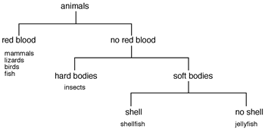
- 2000 years ago, Aristotle was the first taxonomist
  - Aristotle divided organisms into plants & animals
  - He subdivided them by their habitat ---______________________________________ ______________________________________
- Linnaeus developed a naming system using the following:
  - Levels of ___________________________
  - Based groupings on morphological (__________________) differences of organisms
  - Divided organisms into two groups: _________________________________________________
- Today, scientists use Linnaeus’s system – the binomial system of nomenclature.
  - Nomenclature = _____________________ (putting organisms into named groups!)
- This system is based on a ranking system or hierarchy
  - Modern system is called the binomial system (bi = _________ ; nom = ____________)
  - These names include the ___________________ and the ________________________
- When writing the scientific name of an organism, both words must be underlined or italicized. The genus is always _______________________________, and the species always begins with a _____________ case letter.
  - Homo sapiens = ____________________________________
  - Felis domesticus = _______________________________________
- Scientific names are always written in ______________ or ancient ________________ so that they have the same name everywhere!
  - Can abbreviate the genus with one letter (ex: H. sapiens)
- Genus = a group of __________________________________________________
  - How did we define a species in our evolution notes? (organisms able to interbreed)
- Scientific names may ____________________________ the organism (Ex: Chaos chaos)
- They may also honor a ____________________ or suggest the __________________________ of the organism (Linnaea borealis)
- Accurately & uniformly names organisms
- Prevents misnomers such as starfish & jellyfish that aren't really fish

- Classification Groups
- Taxon ( taxa-plural) is a category into which ______________________________ organisms are placed
- There is a hierarchy of groups (taxa) from broadest to most specific:
Domain, Kingdom, Phylum, Class, Order, Family, Genus, species
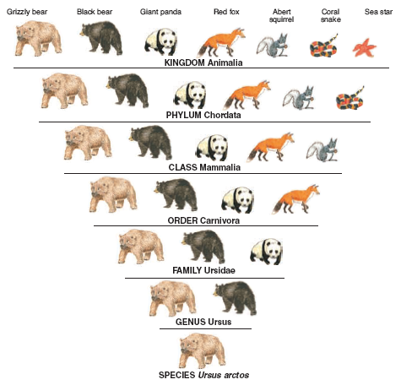
    - The largest group is the ____________________, and the smallest group is the ______________
      - Each kingdom (plant and animal) was divided into phyla (plural for phylum)
      - Each phylum into a smaller groups called class.
      - Each class was divided into orders.
      - Each order was divided into families.
      - Each family was divided into genera (plural for genus)
      - Each genus was divided into species. (scientific name)
Memory Trick: King Phillip Came Over For Good Soup

- Domains
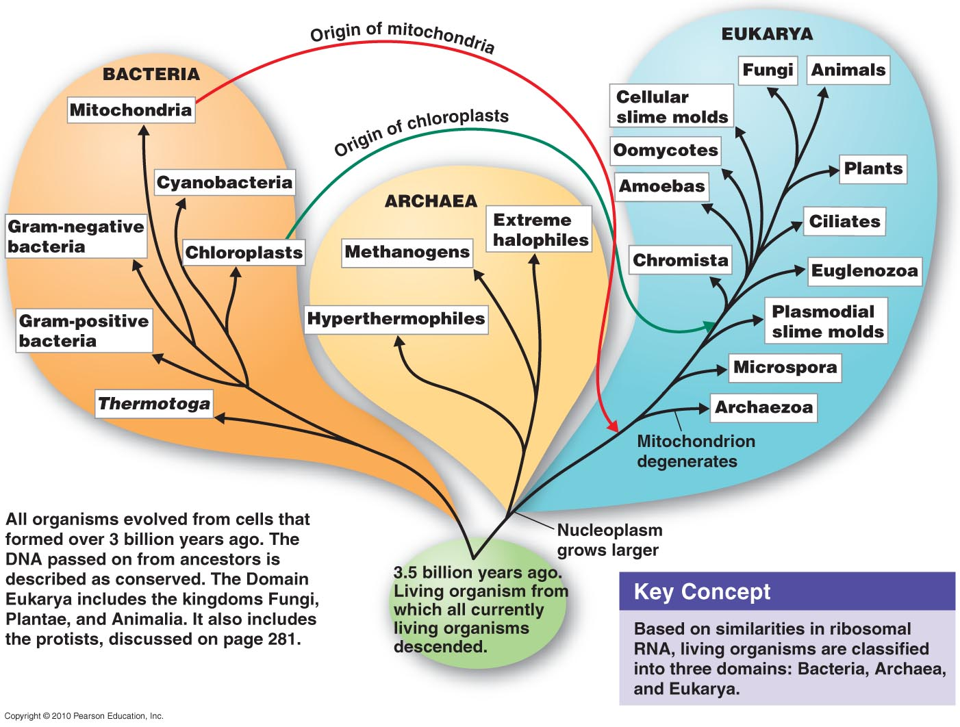
- __________________, most inclusive taxon
- ______________ domains
- Archaea and Bacteria are unicellular ___________________________ (no nucleus or membrane-bound organelles)
- Eukarya are more complex and have a nucleus and membrane-bound organelles

- The Kingdoms
- Archaebacteria
  - Probably the 1st cells to evolve
  - Live in _________________ environments
  - Found in:
    - Sewage Treatment Plants (Methanogens)
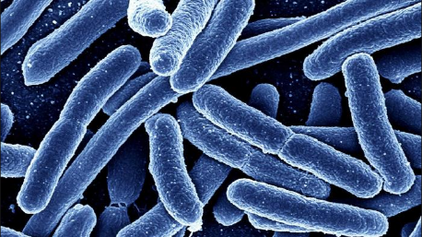
    - Thermal or Volcanic Vents (Thermophiles)
    - Hot Springs or Geysers that are acid
    - Very salty water (Dead Sea; Great Salt Lake) – Halophiles

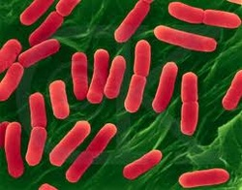
- Eubacteria
  - Some may cause ___________________________
  - Found in ALL HABITATS except harsh ones
  - Are both ______________________________________________________________
  - Important ___________________________ for environment
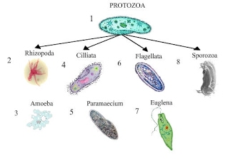
  - Commercially important in making cottage cheese, yogurt, buttermilk, etc.
- Protista
  - Most are __________________________________
  - Some are __________________________________
  - Some are autotrophic, while others are heterotrophic
  - Aquatic
- Fungi
  - ________________________________, except yeast
  - Absorptive _________________________________ (digest food outside their body & then absorb it)
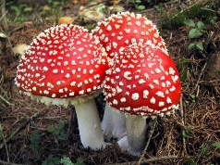
    - obtain their nutrients by releasing digestive enzymes into a food source.
    - They absorb their food after it has been digested by the enzymes.
  - Cell walls made of ____________________________
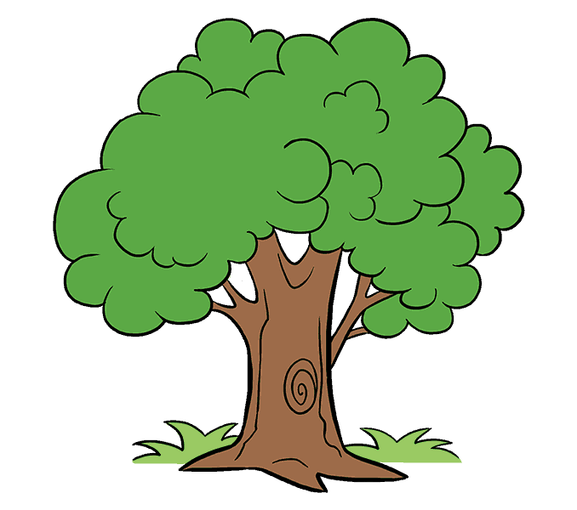
- Plantae
  - ________________________________________
  - _______________________________________ Absorb sunlight to make glucose (photosynthesis)
  - Cell walls made of ________________________________________
  - Kingdom Plantae includes mosses, ferns, cone-bearing plants (_______________________________), and flowering plants (_____________________________________________).
- Animalia
  - _______________________________
  - Ingestive _______________________________________ (consume food & digest it inside their bodies)
    - Feed on plants or animals
  - Most members of the Animal Kingdom can move from place to place.
    - Some are permanently attached to surfaces such as sponges and barnacles.
  - Fish, Birds, Reptiles, Amphibians, and mammals-including humans belong to the Kingdom Animalia.
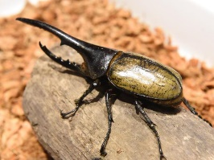
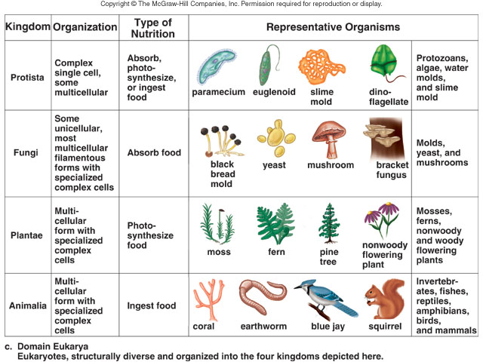
  - This Kingdom also includes sponges, jellyfish, worms, sea stars, and insects.
- Cladograms
- Diagram showing how organisms are related based on shared, derived characteristics such as feathers, hair, or scales
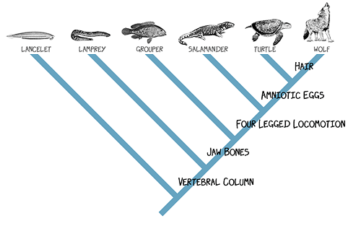
Using the cladogram to the left…
- Which organisms have jaw bones? _______________________________________________
- Which organisms have amniotic eggs? _______________________________________________
- What organism is most closely related to the wolf? _______________________________________________
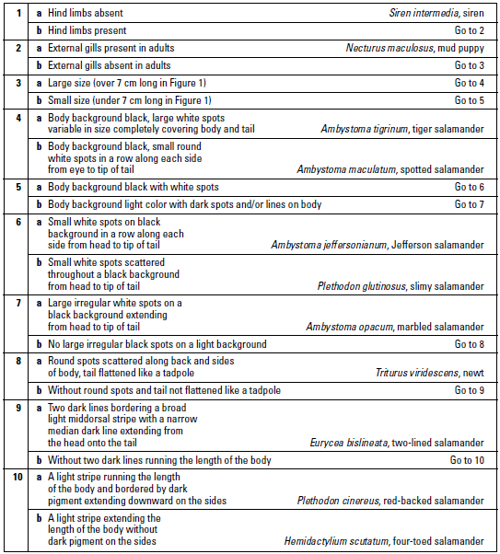
- Dichotomous Key
- Used to ___________________________ organisms
- Characteristics given in __________________ (di = 2)
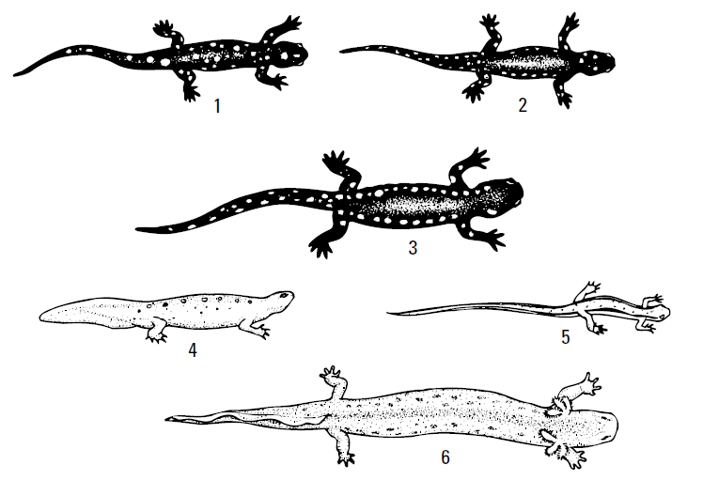
- Read both characteristics and either go to another set of characteristics OR identify the organism
#1: ______________________________
#2: ______________________________
#3: ______________________________
#4: ______________________________
#5: ______________________________
#6: ______________________________

