Name: _______________________________________________ Date: ___________________________ Period: _____

**Unit 9 Notes, Part 2: Human Genetics**

AP Biology

1. **What if there are more than two alleles for a particular gene?**
2. Sometimes there are more than two alleles for a particular gene. We call this inheritance pattern “**multiple alleles.”** For example, there are three alleles controlling human blood type—A, B, and O. Since A and B are both dominant to O, we often use the following symbols to denote the three alleles:

|  |  |
| --- | --- |
| **Allele** | **Symbol** |
| A | IA |
| B | IB |
| O | i |

1. An “A” allele codes for A type **antigens** (carbohydrates, proteins, glycoproteins or glycolipids) on the surface of your red blood cells. The A allele also codes for **antibodies** in your blood plasma (fluid) that can attach to B type antigens. These are called Anti-B antibodies.
2. A “B” allele codes for B type antigens on the surface of your red blood cells. The B allele also codes for antibodies in your blood plasma that can attach to A type antigens. These are called Anti-A antibodies.
3. An “O” allele does not code for any antigens but does code for both Anti-A and Anti-B antibodies in the blood plasma.
4. Every individual has two alleles for blood type. Because both A and B are dominant to O, an individual must receive two copies of the recessive O allele to have blood type O. Because A and B are codominant, an individual with blood type AB will have both A and B type antigens on the surface of his/her blood cells (but no antibodies). Below is a summary of the allele combinations, blood types, antigens present, and antibodies present.

|  |  |  |  |
| --- | --- | --- | --- |
| **Allele Combination** | **Blood Type** | **Antigens on the Surface of Red Blood Cells** | **Antibodies in the Plasma** |
| AA / IA IA  Or  AO / IAi | A | A antigens | Anti-B Antibodies |
| BB / IB IB  Or  BO / IBi | B | B antigens | Anti-A Antibodies |
| AB / IA IB | AB | A and B antigens | None |
| OO / ii | O | None | Anti-A and Anti-B Antibodies |

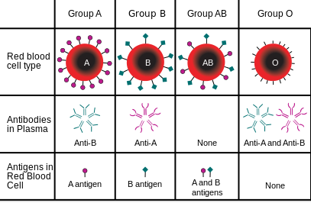

1. **Rh factor** is also a part of your blood type. Individuals that are Rh positive (+) have an Rh factor antigen on the surface of their red blood cells, whereas individuals that are Rh negative (-) do not. However, individuals who are Rh negative (-) have Anti-Rh antibodies in their blood plasma.
2. If Rh factor is considered as well, there are 8 possible blood types: A+, A-, B+, B-, AB+, AB-, O+, and O-.
3. If a person receives a blood transfusion, they are given only red blood cells from the donor blood (not plasma). If the recipient has plasma antibodies that match with the antigens on the surface of the donor red blood cells, this will cause clumping in the blood called **agglutination** that can kill the recipient.
4. Because people with AB+ blood type have no antibodies in their blood plasma, they are considered the “**universal recipient**.” In other words, they can receive transfusions of blood from any blood type because there is no risk of agglutination.
5. Because people with O- blood type have no antigens on the surface of their red blood cells, they are considered the “**universal donor**.” In other words, they can donate blood to a recipient with any blood type because there is no risk of agglutination.
6. Back to genetics, below is an example Punnett square problem tracking the inheritance of blood type…

A woman has blood type A, but her father had blood type O. A man has blood type AB. If the man and woman get married and have children, what is the chance that their children will have blood type B?

*Note: The woman must have an A and an O allele because her father could only give her an O allele.*

|  |  |  |
| --- | --- | --- |
|  | **A** | **O** |
| **A** | AA | AO |
| **B** | AB | BO |

*\*Answer: Their children have a 25%(1/4) chance of having blood type B.*

1. **What are some other “Non-Mendelian” patterns of inheritance seen in humans and other organisms?**
2. Some traits demonstrate **pleiotropy**, which is when one gene produces more than one phenotypic (physical) effect. For example, phenylketonuria is a human disease that is caused by one gene defect (mutation) but has effects on multiple systems. People with this disease lack the enzyme used to break down the amino acid phenylalanine. This results in cognitive deficits, smaller head size, and lighter hair color.
   1. *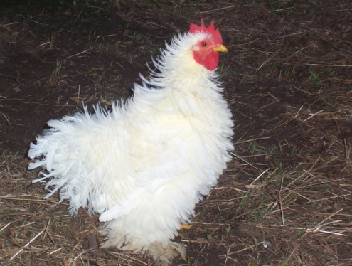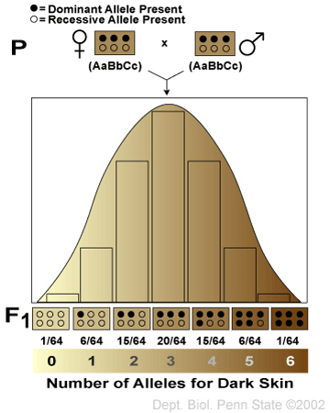Another example of pleiotropy involves the dominant “frizzle” gene in chickens, which produces feathers that curl outward rather than lying flat against their bodies. In addition to causing abnormal feathers, this gene causes chickens to have abnormal body temperatures, higher metabolic and blood flow rates, greater digestive capacity, and lower egg-laying rates.*
3. Some traits demonstrate **polygenic inheritance**, which is when more than one gene determines a phenotype (trait). The more genes that control a particular trait the more variation there can be in the phenotypes. This is the opposite of pleiotropy. Examples of traits determined by polygenic inheritance are height, weight, eye color, and skin pigmentation (see graph to the left).
4. Some traits are controlled by a mixture of genes and **environmental factors**. These are called **multifactorial traits**. For example, weight in humans is controlled by a mixture of genes and diet. Also, hydrangeas (a type of flower) can be pink or blue depending on the pH of the soil (an environmental factor). In acidic soils, the hydrangea plant will produce blue flowers, while in basic soils, the hydrangea plant will produce pink flowers.
5. Some traits are controlled by DNA not found in the nucleus. Therefore, these traits follow a pattern of **nonnuclear inheritance**. Nonnuclear DNA can come from mitochondria or chloroplasts, which are randomly segregated to gametes during meiosis. In humans, the egg brings all the cytoplasm / organelles to the zygote (fertilized egg), so mitochondrial DNA comes solely from the mother.
6. **How can we track the inheritance of a trait through multiple generations?**
7. Scientists use **pedigree** charts to track the inheritance of a trait through multiple generations. You need to be able to analyze existing pedigrees and create pedigrees from information you are given about a family’s traits.
8. Below is a summary of the symbols used in a pedigree chart…

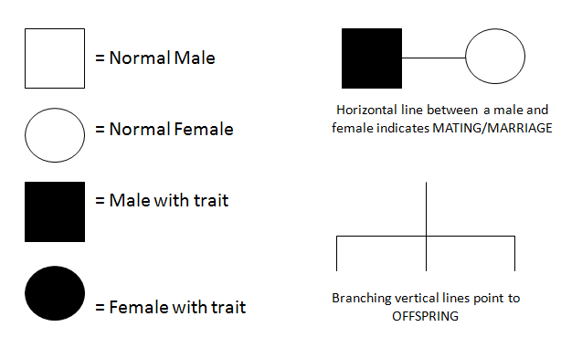

1. If a man or woman has one copy of an allele for a recessive trait, their square or circle may be half shaded (only on some pedigrees). This individual would be considered a “**carrier**,” meaning they do not “show” the trait but they can pass on the allele for the trait to their offspring.
2. There are several patterns of inheritance typically depicted on pedigree charts—autosomal dominant, autosomal recessive, sex-linked dominant (aka X-linked dominant), and sex-linked recessive (aka X-linked recessive). Some pedigrees also show Y-linked traits, which are determined by genes found on the Y chromosome. Only males can display these traits (because only males have Y chromosomes), and they are passed from father to son.
3. **Autosomal dominant** traits are controlled by a dominant allele on an autosome (a non-sex chromosome). Pedigrees that follow this method of inheritance typically show a nearly even distribution of males and females with the trait and NO instances of children with the trait when neither parent displays the trait.

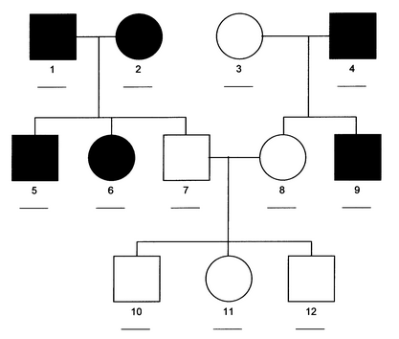Example Pedigree:

1. **Autosomal recessive** traits are controlled by a recessive allele on an autosome. Pedigrees that follow this method of inheritance typically show a nearly even distribution of males and females with the trait and one or more instances of children with the trait when neither parent displays the trait (see arrow). This latter occurrence can be explained by both parents being carriers for a recessive allele, which they both passed on to their child. (Note: This is shown on the Punnett square below, where A = normal, and a = trait)

|  |  |  |
| --- | --- | --- |
|  | **A** | **a** |
| **A** | AA | Aa |
| **a** | Aa | aa |

Example Pedigree:

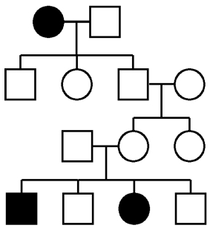

1. **Sex-linked dominant** traits are controlled by a dominant allele on the X chromosome. Pedigrees that follow this method of inheritance will show that only female children of a father with the trait and a mother without the trait will have the trait. (Note: This is shown on the Punnett square below, where XA = trait and Xa = normal.)

*\*\*\*Note: For some reason, it is rare that the AP test will give you a sex-linked dominant pedigree!!!\*\*\**

|  |  |  |
| --- | --- | --- |
|  | **XA** | **Y** |
| **Xa** | XA Xa | XaY |
| **Xa** | XA Xa | XaY |

Example Pedigree:

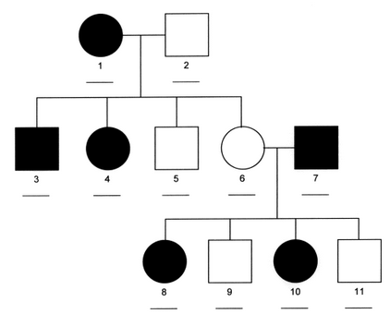

1. **Sex-linked recessive traits** are controlled by a recessive allele on the X chromosome. Pedigrees that follow this method of inheritance will show more males with the trait than females. This is because males only need to receive one copy of the recessive allele to show the trait (because they only have one X chromosome). In contrast, females must receive two copies of the recessive allele to show the trait. If neither parent displays the trait (but the mother is a carrier), only male children can display the trait. Also, if only the mother displays the trait, only male children can display the trait. (Note: Both these scenarios are shown on the Punnett squares below, where XA = normal and Xa = trait)

Case 1: Neither parent displays the trait (but the mother is a carrier)

|  |  |  |
| --- | --- | --- |
|  | **XA** | **Y** |
| **XA** | XA XA | XAY |
| **Xa** | XA Xa | XaY |

Case 2: Only the mother displays the trait

|  |  |  |
| --- | --- | --- |
|  | **XA** | **Y** |
| **Xa** | XA Xa | XaY |
| **Xa** | XA Xa | XaY |

Example Pedigree:

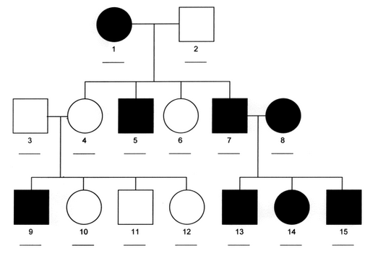

**Case #1**

**Case #2**

1. At any rate, when determining what pattern of inheritance is shown in a pedigree, you may have to try a system of trial and error. In this system you follow the steps listed below:

* Assign your alleles for a particular pattern of inheritance (see chart on the next page).
* Write the genotypes that would correspond to each individual on the pedigree for the chosen pattern of inheritance
* If all the genotypes “work,” this is the correct pattern of inheritance.

|  |  |  |
| --- | --- | --- |
| **Pattern of Inheritance** | **Alleles** | **Possible Genotypes and Associated Phenotypes** |
| Autosomal Dominant | A = trait  a = normal | AA = trait  Aa = trait  aa = normal |
| Autosomal Recessive | A = normal  a = trait | AA = normal  Aa = normal  aa = trait |
| Sex-linked Dominant | XA = trait  Xa = normal | XA XA  = female, trait  XA Xa = female, trait  Xa Xa  = female, normal  XAY = male, trait  XaY = male, normal |
| Sex-linked Recessive | XA = normal  Xa = trait | XA XA  = female, normal  XA Xa = female, normal  Xa Xa  = female, trait  XAY = male, normal  XaY = male, trait |

**Notes Questions**

1. A woman with Type A blood and a man with Type AB blood have a baby. The woman is suing the man for child support, but he is refusing to pay because he says the baby (who has Type O blood) is not his. Is he right or should he be paying child support? Use a Punnett Square to prove your answer.
2. Is it possible for a man with Type A blood and a woman with Type B blood to have a child with Type O blood? Use a Punnett Square to support your answer.
3. Compare and contrast pleitropic inheritance and polygenic inheritance; provide an example of each.
4. 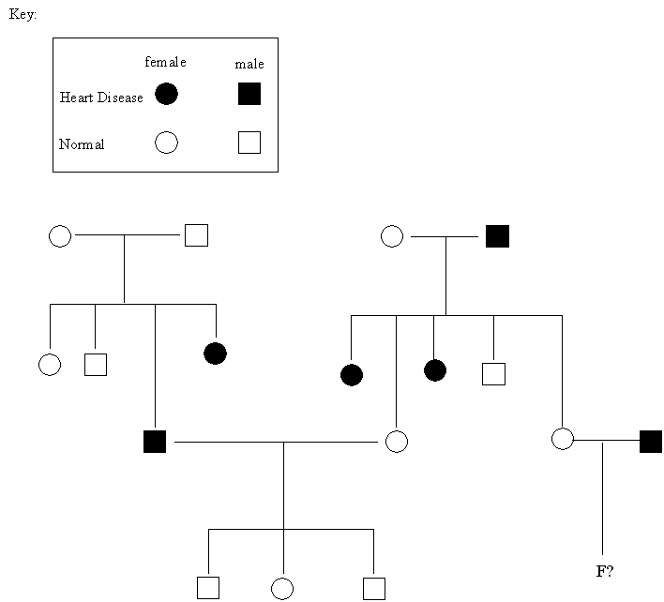To the right is a pedigree for an inherited heart disease.
   1. What type of inheritance pattern is displayed in this pedigree?
   2. What is the probability that their child F would have the inherited heart disease?
5. A **typical pedigree** for a family that carries Falconi anemia is shown below. Note that carriers are **not** indicated with half-colored shapes in this chart (the individuals with slanty lines in their circles or squares **have** the disorder). The genotypes of some individuals are given.

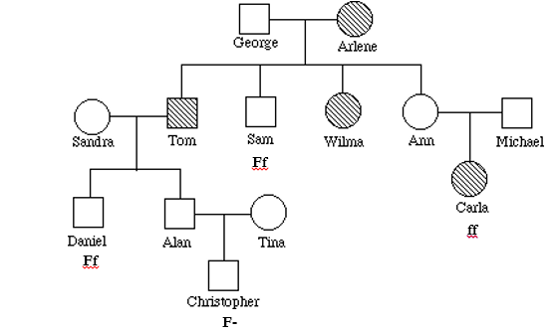

To answer questions below, use the letter "f" to indicate the recessive Falconi anemia allele, and the letter "F" for the normal allele.

a. What is Arlene's genotype?

b. What is George's genotype?

c. What are Ann & Michael's genotypes?

d. What are Sandra’s possible genotypes .

1. A **typical pedigree** for a family that carries neurofibromatosis is shown below. Note that carriers are **not** indicated with half-colored shapes in this chart. Use the letter "N" to indicate the dominant neurofibromatosis allele, and the letter "n" for the normal allele. The genotypes of some individuals are given.

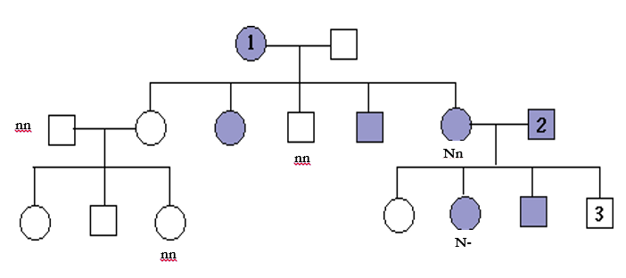

1. Is individual #1 most likely homozygous dominant or heterozygous? Explain how you can tell.
2. What is the genotype of individual #3?
3. Can you be sure of the genotypes of the affected siblings of individual #3? Explain.
4. **Draw Maureen’s Pedigree**

* **Trait:** blood type -- Blood type is determined by the presence of several different proteins found on the surface of red blood cells. Blood type “A” has the A protein; blood type “B” has the B protein; blood type AB has both; blood type O has neither. The +/- indicates another protein called Rh.
* **Forms of the trait:** inheritance via autosomal multiple allelism (A, B, or O) results in the blood types A, B, AB or O. The alleles for blood protein A and B are codominant, the "O" allele is recessive to both the A and B alleles.
* Use **AA, AO, AB, BB, BO or OO to represent the genotypes** of all individuals that you show in the pedigree you draw**.** For some individuals, you will include their names in the pedigree. Some individuals will be unnamed.You do not need to shade in any circles and squares.

As a high school project, **Maureen** decides to trace the inheritance of blood types through her extended family, all the way back to her great-grandmother Katherine. Here’s what Maureen found out….

Maureen’s great-grandmother Katherine, has A type blood. Katherine and her husband John had four children – two sons, Michael (who has blood type AB) and David (who has type O blood); a daughter (Jessica) with type O blood and another daughter (Jennifer) with type A blood. Jessica never married; her sister Jennifer did get married and had three sons (one with type A blood, one with type AB blood and one with type O blood). Both of Katherine's sons also get married – Michael marries a woman with type O blood and together they have two daughters (Anna – type A; Leanne – type B); David marries a woman with type A blood, and they have three children (daughter Fran and son Albert who both have type A blood, and a son Matthew with type O blood). Matthew marries Janine and together they have one daughter, **Maureen**. Maureen knows that her parents both have the same blood type, but she has never yet had a blood test to determine her own blood type.

* 1. Draw her pedigree in the space below.
  2. **What does Maureen’s blood type have to be? How do you know?**