Name: _________________________________________ Unit 8 Topic 2
Period: _______ Page: _______
Unit 8 Topic 2 Review: Evolution
Define evolution: The ______________ in _______________________ over time.
What is a population? _________________________________________________________________________ ___________________________________________________________________________________________

Subtopic 1: Lamarck and Darwin’s Theories
Scientist | Theory (name and description) | Example
Jean Baptiste Lamarck

Charles Darwin

How are Darwin’s finches related to evolution? ______________________________________________________________________________________________________________________________________________________________________________________________________________________________________________________________________________________________________

Subtopic 2: Evidence for Evolution
Evidence | Picture | Describe
Fossils | 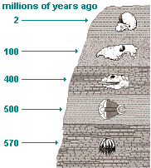 | What is a fossil?  What can we learn from them?
Comparative Anatomy | 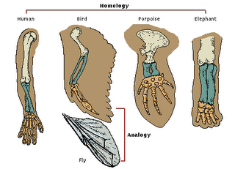 | Define and provide an example of…  - Homologous Structures:  - Analogous Structures:  - Vestigial Structure
Comparative Biochemistry | 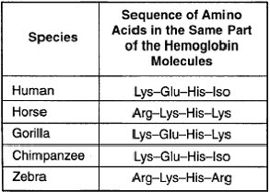 | What is comp. biochemistry?  How can you tell if organisms are closely related or not?
Comparative Embryology | 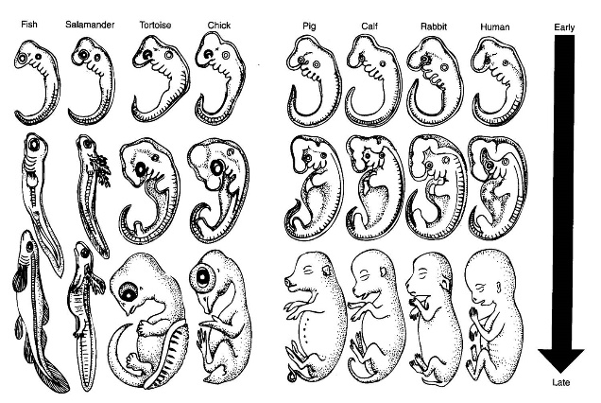 | Define Embryo:  What do you look for in comp. embry?
Subtopic 3: Speciation
- Define species: ___________________________________________________________________________________________
- What is speciation? ___________________________________________________________________________________________
  - Compare geographic isolation and reproductive isolation: __________________________________________________________________________________________________________________________________________________________________________
  - Compare gradualism with punctuated equilibrium: _______________________________________________________________________________________________________________________________________________________________________________________________________________________________________________________________
  - Coevolution (define and example): _____________________________________________________________________________________
  - Contrast Convergent and Divergent evolution: __________________________________________________________________________________________________________________________________________________________________________
  - Adaptive radiation (define, example): __________________________________________________________________________________________________________________________________________________________________________
- Explain artificial and sexual selection: ______________________________________________________________________________________________________________________________________________________________________________________
- Discuss the three types of natural selection (stabilizing, directional, disruptive) and draw an image for each: _________________________________________________________________________________________________________________________________________________________________________________________________________________________________________________________________________________

