Name: _______________________________________ Unit 1 Topic 2
Period: _______ Page: ______
Water vs. Acetone Mini Lab
Properties of Water Reintroduction

In this station-based lab, you’ll do a small interaction with these two chemicals for each of the properties of water to refresh what you learned in biology. Use your group to help you figure out how each station relates to a specific property of water.

- Adhesion & Cohesion:
Dip your index finger into the acetone and then the liquid between your thumb and index finger. Slowly pull them apart like you see in the picture below. Draw a picture of what the acetone looks like as you pull your fingers apart. Repeat this process with water. (You may want to do both at the same time to compare)

Explain how adhesion and cohesion contributed to the results of this small test:

Water
Acetone

- Surface Tension:
Using a pipette, count the number of drops of acetone that can be held on the heads surface of a clean and dry penny. Record that number in the table below. Once you have finished with acetone, clean and dry the penny and then repeat with water.
Number of Drops Held on the Penny
Acetone | Water

- Capillary Action:
Below is a data set gathered when a capillary tube was inserted into a cup of each of the substances. A plastic ruler was used to measure how high each substance climbed up the tube over the next 4 minutes.
Time | Height of Acetone (red) in Tube | Height of Water (blue) in Tube
0 minutes (initial) | 0.7 cm | 1.5 cm
1 minute | 0.8 cm | 2.0 cm
2 minutes | 0.8 cm | 2.3 cm
3 minutes | 0.9 cm | 2.6 cm
4 minutes | 1.0 cm | 3.0 cm

- Based on the evidence, water can climb faster through small tubes. Explain how it is capable of doing that (use the words adhesion and cohesion in your answer).
______________________________________________________________________________________________________________________________________________________________________________________________________________________________________________________________________________
- Apply this knowledge to water traveling where it needs to in plants.
____________________________________________________________________________________________________________________________________________________________________________________
- Density of Water as a Solid
Look at the graphs below and explain the pattern for the density of acetone as a solid versus a liquid. Do the same for water. Explain why water’s low density as a solid is important in the natural world.
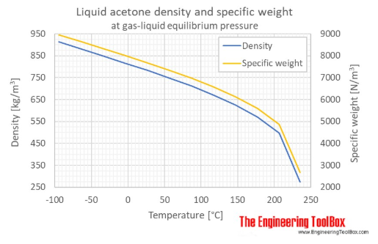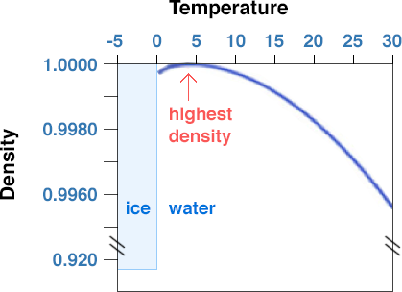
Acetone Water

Explain how the density of acetone as a solid compares to its density as liquid. Also address how the density of water as a solid compares to its density as a liquid.
____________________________________________________________________________________ ________________________________________________________________________________________________________________________________________________________________________
____________________________________________________________________________________

Why is water’s low density important in the natural world?
____________________________________________________________________________________ ____________________________________________________________________________________________________________________________________________________________________________________________________________________________________________________________

- Evaporation:
Dip your fingertip into the sample of acetone. Using your wet finger, draw a streak on the table top and watch what happens.
Now you are going to repeat this process two times. Once with the acetone again and once with water. (You want the streak you draw to be as similar as possible both times). Use a timer to record how long it takes each streak to evaporate.

Length of Time to Evaporate (include your units!)
Acetone | Water
*If a measurement takes more than 2 minutes, just write “ >2 mins ”

How does hydrogen bonding explain the difference in the time it takes for the two substances to evaporate?
____________________________________________________________________________________________________________________________________________________________________________________________________________________________________________________________
- High Heat Capacity / Evaporative Cooling:
Wrap a strip of paper towel around the bulb of your thermometer and hold it in place with a rubber band. Dip the thermometer into the beaker of acetone and record the temperature. Once you have the initial temperature recorded, pull the thermometer out, lay it on the table, and record the temperature every thirty seconds for three minutes. Record and graph your data below. Once you are done with acetone, repeat this process with water. (Make the acetone graph with red dots/line and the water graph with blue.)
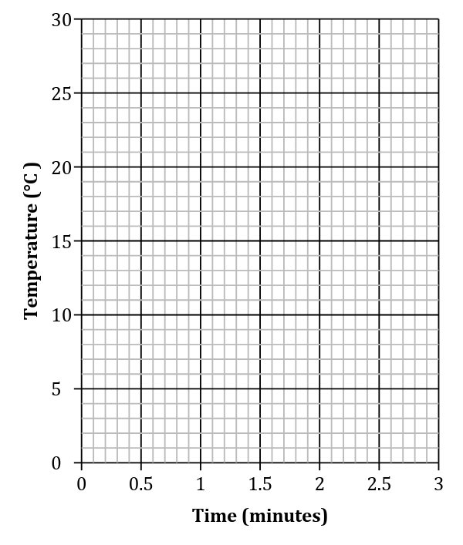
Acetone |  | Water
Time (min) | Temperature (°C) | Time (min) | Temperature (°C)
0 |  | 0
0.5 |  | 0.5
1 |  | 1
1.5 |  | 1.5
2 |  | 2
2.5 |  | 2.5
3 |  | 3

What is specific heat? Specific heat is the amount of energy required to raise or lower 1.0 gram of a substance 1.0 degrees Celsius.

Which substance has a higher specific heat / heat capacity?
______________________________

Put into your own words how hydrogen bonding is responsible for the results of this heat capacity experiment.

____________________________________________________________________________________________________________________________________________________________________________________________________________________________________________________________________________________________________________________________________________________________________________________________________________________________________________________________________________________________________________________________________________________________

- pH
Take a small sample of each of the bottled waters and use a pH strip to find its pH. Once you’ve got the pH measurement, calculate the concentration of H⁺ ions in each of the samples.

